Woodland Wanderers Handbook

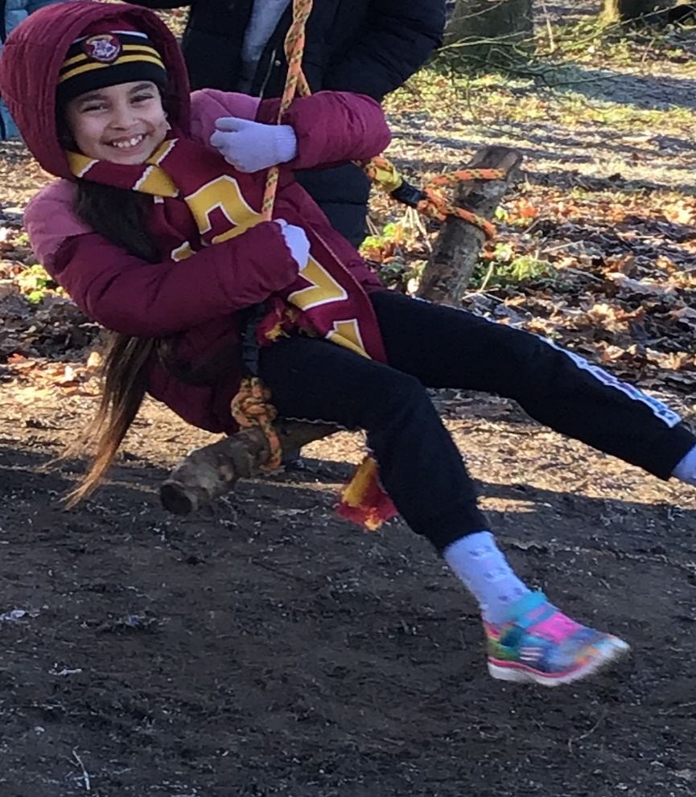

Created by Sfarish December 2022 To be reviewed annually Last amended on 06/12/2022
Contents Page

Page Number | Contents
1 | Front Cover
2 | Contents Page
3 | What is Woodland Wanderers?
4 | Operating Woodland Wanderers whilst minimizing the impact and maintaining sustainability
5 | Woodland Wanderers Health and Safety – Ratios, risk management/assessment procedure, first aid procedure
6 | First Aider list
7 | Lost or missing child Procedure, toileting/Hygiene procedure
8 | medical consent, Record/Filing of parental/carer permission for photos, insurance,
9 | Tools procedure
10 | Secateurs Procedure
11 | Peelers Procedure
12 | Tree Climbing procedure
13 | How to climb a tree safely
14 | Palm Drill Procedure
15 | Rope Swing Procedure
16 | Hammer and nails procedure
17 | Hammer and nails procedure continued
18 | Daily Operating Procedure – what to do before the session, clothing
19 | Woodland Wanderers session plan
20 | Woodland Wanderers session plan continued, What to do during the session, What to do at the end of the session
21 | Daily Safety Check List
22 | Safeguarding children at Forest School
23 | Safeguarding children at Forest School continued
24 | Safeguarding children at Forest School continued
25 | Safeguarding children at Forest School continued
26 | Confidentiality Procedure
27 | Equality Procedure
28 | Behaviour Policy and Procedure
29 | Behaviour Policy and Procedure continued

30

Created by Sfarish December 2022 To be reviewed annually Last amended on 06/12/2022
What is Woodland Wanderers?

Woodland Wanderers offers the children opportunities to succeed and develop confidence and self-esteem through hands-on learning in a woodland environment. Children will engage in play, learn boundaries of behaviour, and grow in confidence, self-esteem and motivation whilst developing an understanding of the natural world.

Children who take part in Woodland Wanderers are seen as

- Equal, unique and valuable
- Competent to explore and discover
- Entitled to experience appropriate risk and challenge
- Entitled to choose, and to initiate and drive their own learning and development
- Entitled to experience regular success
- Entitled to develop positive relationships with themselves and other people
- Entitled to develop a strong, positive relationship with their natural world.

Woodland Wanderers is an inspirational process that offers ALL learners regular opportunities to achieve and develop confidence and self-esteem. At Wicklewood we

- Develop personal and social skills
- Work through practical problems and challenges
- Use tools to create, build or manage
- Discover how they learn best
- Pursue knowledge that interests them
- Learn how to manage failures
- Build confidence in decision making and evaluating risk
- Develop practical skills
- Understand the benefits of a balanced and healthy lifestyle
- Explore connections between humans, wildlife and the earth
- Regularly experience achievement and success
- Reflect on learning and experiences
- Develop their language and communication skills
- Improve physical motor skills
- Become more motivated
- Improve their concentration skills

Created by Sfarish December 2022 To be reviewed annually Last amended on 06/12/2022
Operating Woodland Wanderers whilst minimizing the impact and maintaining sustainability
Woodland Wanderers can harm the outdoor area especially with consistent, long-term use. There is the harm of trampled vegetation when children are running around the area which will kill off areas of the ground layer, impacting the growth of rare plants and foliage. This will destroy some animal and insect habitats. Tree climbing, shelter building and swings can cause damage to trees over a period. Children also like to pick leaves and flowers to collect but this will harm the plants etc. within the woodland.
To minimise the impact on the woodland and field area here at Wicklewood as well as the surrounding areas: -
- Children are made aware of where they are walking and what they are standing on to reduce the impact on vegetation, especially any flowers and plants that may be growing and providing a habitat for bugs/insects or providing food for animals.
- A swing is hung from a specific tree that will tolerate and withstand the usage. Occasionally an alternative tree will be used in order to minimize damage.
- Children are not to pick the flowers as we have a limited supply to observe and draw. We plant lots of different plants and flowers for the children to take care of and watch grow. We also sew wild flower seed to encourage pollinators.
- Any water needed for mud play is sourced using water butts to ensure we are kind to the environment in not wasting tap water.
Higher demands on smaller areas mean that woodlands are at risk of being over used, depleted of resources and therefore the species and ecosystems will change or become extinct in the area. This is why it is important to manage and maintain sustainability of the area.

Created by Sfarish December 2022 To be reviewed annually Last amended on 06/12/2022

Woodland Wanderers Health and Safety
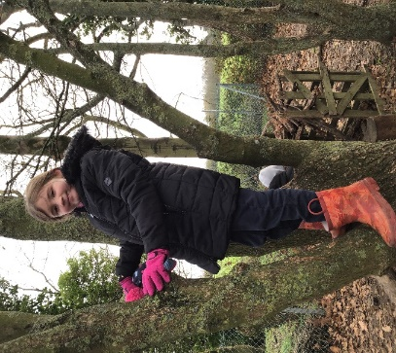
Ratios
Sara Star (Ms Farish a level 3 forest schools lead) will oversee this and run some of the sessions. Alongside me will be 2 members of staff.

Risk Management and Assessments Procedure
Sara Star is responsible for the risk assessments. There is a general site risk assessment and a termly risk assessment. Risk/benefit assessments will be completed for activities such as tree climbing. Risk/benefit assessments for individual children will be carried out as necessary. As part of the risk assessment process the risk benefit also needs to be considered. This is analysing each activity and deciding whether the benefits to the children’s learning outweighs the risk involved. A certain level of risk in our lives is accepted as necessary to achieve certain goals.

First Aid Procedure
A first aid kit will be taken out with the group, additional first aid kits are stored within the school building. School first aid policies and procedures will be followed in the event of an accident and these can also be found in the school office. All accidents are recorded and bumped head notes filled in and sent home when necessary. All staff will be made aware of any medical conditions of the children, inhalers, epi pens etc. will be left in the school building unless specifically required for those children with severe medical requirements.
Contact details are stored on pupil asset, which all staff have access to.

Created by Sfarish December 2022 To be reviewed annually Last amended on 06/12/2022
The following LSA’s are first aid qualified:-

Created by Sfarish December 2022 To be reviewed annually Last amended on 06/12/2022

Accident and Emergency Procedure
In the case of a serious accident or emergency, a member of staff will remain with the injured party. The office staff will be informed so they can phone parents and an ambulance if it is required. Contacts of all children and staff as well as volunteers will be accessible from the school office. Our accident and emergency policy will also be followed in line with the school. This can also be found in the school office.

Lost or missing child procedure
As the Woodland Wanderer sessions are based within the school grounds, there is no risk of losing a child. The school premises is locked at all times during school hours so if a child chooses to run off they would only be able to leave the school grounds if they climbed a school fence. If this was to occur then an adult would stay close to the child and SLT will be informed.
Toileting and hygiene Procedure for site within school grounds
Children will be encouraged to visit the toilet before we leave the school building and enter the Forest school site. Children can visit the toilets if necessary during the session accompanied by an adult. Hand Washing takes mplace in the classroom so hot water can be used.

Created by Sfarish December 2022 To be reviewed annually Last amended on 06/12/2022

Record and Filing of Parental/Carer consent including medical consent
Medical consent is required when the children enrol with the school and is held in the school office under the child’s profile. Children with medication will already have a medication consent form at school.




 ! 
""
#$%!
#&

'(
# 
)
)
)*+ ,
)
)
)**
--
.
/01
2"
!3






 ! 
""
#$%!
#&

'(
# 
)
)
)*+ ,
)
)
)**
--
.
/01
2"
!3






 ! 
""
#$%!
#&

'(
# 
)
)
)*+ ,
)
)
)**
--
.
/01
2"
!3


Record and filing of Parent/Carers permission for photos/Videos
Parent’s enrolment forms include a section giving permission for photos and videos to be taken. Permission for photos to be used in coursework if ever needed would however be a separate letter to be sent out for authorisation. Photos/videos are taken on school ipad’s and the photos are stored either on the staff server and/or on google drive – both of which are secure and can only be accessed by staff. Please see the code of conduct policy for further information.
Insurance
Public liability insurance is with Zurich Municipal via Norfolk County Council
1st April 2022 to 31st March 2023

Steve Rayner - Insurance Manager
Ground Floor
County Hall Annexe
Martineau Lane
Norwich
NR1 2UE

Created by Sfarish December 2022 To be reviewed annually Last amended on 06/12/2022
Tool Use Procedure
Sara Star will train the adults in the use of each tool before they introduce it to the children. Tools will be counted in and out. Tools will be stored safely and kept out of the reach of children. They will be cleaned after each use to prolong their life, broken and damaged tools will not be used. Children and adults will be informed of rules and safety before they use them.
Tools will be used on a ratio of 1 adult to 2 children.
Tool procedures and risk/benefit assessment will be added as necessary.

Created by Sfarish December 2022 To be reviewed annually Last amended on 06/12/2022
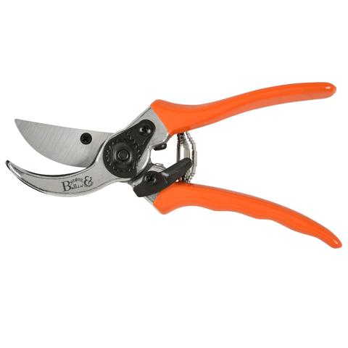
Secateurs Procedure –
For cutting twigs smaller than a penny.
Skills supported Improved fine and gross motor skills, spatial awareness.

How to use it safely

• No gloves on tool hand; well-fitting glove on non-tool hand. Gloves need to be a really good fit otherwise grip on the working material can be compromised.

• Maintain safe distance. Always use tools at a distance at arms’ length and one tool’s length away from other people – Blood Bubble.

• Establish expected behaviour: To ensure everyone clearly understands all instructions and expected behaviour for safe tool use. Anyone misusing a tool intentionally will be required to put down the tool, and step away, until they are ready to behave appropriately and join in again.

• Ensure proper demonstration and supervision.

• Ensure the secateurs are used correctly so they are smiling (As above picture).

• If it is a long stick ask a friend to help you hold it.

• To put down, close and lock safety catch and return to the designated place.

Passing Holding blades in gloved hand, offer handle to person.

Placing Always return it to its designated place when not in use.

Cleaning Use cloth and WD40 to ensure all dirt and moisture is off the blade.

Storing Store in the Tool bag provided.

Created by Sfarish December 2022 To be reviewed annually Last amended on 06/12/2022
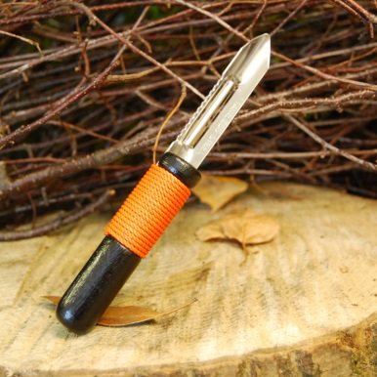
Peelers Procedure –
For whittling small soft sticks and peeling bark.
Skills supported Improved fine and gross motor skills, spatial awareness.

How to use it safely

• No gloves on tool hand; well-fitting glove on non-tool hand. Gloves need to be a really good fit otherwise grip on the working material can be compromised. It is better to have no glove and a safer grip than a glove that is too big.

• Maintain safe distance. Always use tools at a distance at arms’ length and one tool’s length away from other people – Blood Bubble.

• Establish expected behaviour: To ensure everyone clearly understands all instructions and expected behaviour for safe tool use. Anyone misusing a tool intentionally will be required to put down the tool, and step away, until they are ready to behave appropriately and join in again.

• Ensure proper demonstration and supervision.

• You must remain seated. Keep the blade facing away from you on the outside of your wood, on the outside leg peeling away from the body.

Passing Hold blades in gloved hand and offer handles to other person. Do not walk around with the peeler.

Placing Put the tool down on ground or surface with handle facing backwards, or return it to its designated place.

Cleaning Use gloved hand to clear out any wood & dust in the blade of the peeler. Use cloth and WD40 to ensure all dirt and moisture is off the blade.

Storing Store in a tray in the storage container.

Created by Sfarish December 2022 To be reviewed annually Last amended on 06/12/2022

Tree Climbing Procedure
If a child wishes to climb a tree, they need to do it independently. An Adult may show children where to put their feet and give verbal encouragement but they may not help children to climb.
If a child has climbed up the tree and panics, an adult will help them by giving step-by-step instructions on how to get themselves down. If a child is very distressed and cannot get down then an adult may lift them down taking care of their own back.
One child may climb up and down at a time and the rest of the group need to keep a safe distance.
If a child falls from a tree, the Leader will administer first aid. Parents to be informed and a decision made whether the child needs to go home if necessary.

How to climb a tree safely – up to 1.5 metres

• Put your foot in the lowest foothold and your hand on a branch or handhold. Always have 3 points of contact when climbing i.e. 3 limbs should always be connected to a branch. Lift your weight a little bit before lifting your body up to test the handhold or branch strength.

• Pull your other foot up to a higher foothold and lift your body.

• Use your hands to establish a safe position on your chosen branch.

• Sit on the branch or stand up whilst always holding on - never let go.

• Face the tree to get down. • Feel the foothold with your foot and put your weight on it when it feels safe. Continue putting one foot underneath the other until your feet hit the floor.

• Well done- you have climbed a tree!

Created by Sfarish December 2022 To be reviewed annually Last amended on 06/12/2022
How to climb a tree safely – As high as the mark on the tree

• Put your foot in the lowest foothold and your hand on a branch or handhold. Always have 3 points of contact when climbing i.e. 3 limbs should always be connected to a branch.

• Lift your weight a little bit before lifting your body up to test the handhold or branch strength.

• Pull your other foot up to a higher foothold and lift your body.

• Use your hands to establish a safe position on your chosen branch.

• Sit on the branch or stand up whilst always holding on- never let go.

• Face the tree to get down.

• Feel the foothold with your foot and put your weight on it when it feels safe.

• Continue putting one foot underneath the other until your feet hit the floor.

• Well done- you have climbed a tree!

Created by Sfarish December 2022 To be reviewed annually Last amended on 06/12/2022
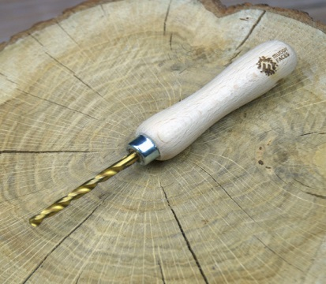
Palm drill Procedure –
For drilling holes into wood.
Skills supported Improved fine and gross motor skills, spatial awareness.

How to use it safely

• No gloves on tool hand; well-fitting glove on non-tool hand. Gloves need to be a really good fit otherwise grip on the working material can be compromised. It is better to have no glove and a safer grip than a glove that is too big.

• Maintain safe distance. Always use tools at a distance at arms’ length and one tool’s length away from other people – Blood Bubble.

• Establish expected behaviour. To ensure everyone clearly understands all instructions and expected behaviour for safe tool use. Anyone misusing a tool intentionally will be required to put down the tool, and step away, until they are ready to behave appropriately and join in again.

• Ensure proper demonstration and supervision.

•You must remain seated. Keep the tip of the drill facing away from you.

• Use a suitable hard surface to place the wood on in order to drill through.

• Always keep in designated place.

Passing Holding tip with gloved hand, offer handle to person. Do not walk around with the Palm drill.

Placing Always return it to its designated place when not in use.

Cleaning Use cloth and WD40 to ensure all dirt and moisture is off the blade.

Storing Store in the Tool bag provided.

Created by Sfarish December 2022 To be reviewed annually Last amended on 06/12/2022
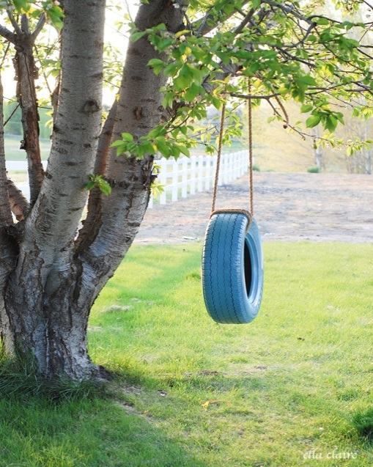
Rope Swing Procedure –
For children to take a risk
Skills supported Improved gross motor skills, Taking a risk, risk assessing.

Children will not be allowed on the rope swing if:
- There is dead wood in the tree canopy.
- Their clothing is unsuitable including wearing jewellery and flimsy footwear- easily caught on tree or swing.
- An adult is not within sight- an adult must be able to supervise this activity, even from a distance.

Woodland Wanderers offers children the opportunity to manage risk, therefore if a child wishes to use the rope swing they need to do it independently.
An Adult may show children where to put their feet and give verbal encouragement but they may not help the children.
If a child is on the rope swing and panics or can’t get off, encourage them to ask their friends to help them where possible and an adult can give step by step instructions on how to get themselves off. If a child is very distressed and cannot get off or stop the swing independently then an adult may intervene and lift them down, taking care of their own back.
One child may be on the swing at a time and the rest of the group need to keep a safe distance.
If a child falls from the swing an adult must ensure the child isn’t hurt and if necessary, the Leader will administer first aid. Parents will always be informed if a serious injury occurs as soon as possible to decide whether the child needs to go home.

Created by Sfarish December 2022 To be reviewed annually Last amended on 06/12/2022

Hammer and Nails Procedure
To construct. Joining pieces of wood together.

Skills supported Improved fine and gross motor skills, spatial awareness.

How to use it safely

• No gloves on tool hand; well-fitting glove on non-tool hand. Gloves need to be a really good fit otherwise grip on the working material can be compromised.

• Maintain safe distance. Always use tools at a distance at arms’ length and one tool’s length away from other people – Blood Bubble.

• Establish expected behaviour: To ensure everyone clearly understands all instructions and expected behaviour for safe tool use. Anyone misusing a tool intentionally will be required to put down the tool, and step away, until they are ready to behave appropriately and join in again.

• Ensure proper demonstration and supervision.

• Ensure the hammer is being used correctly.

• If need be ask a friend to help you hold the wood in place, ensuring hands are a distance from the nail that is being hammered.

• To return to the designated place.

Passing Offer handle to person.

Placing Always return it to its designated place when not in use.

Cleaning Use cloth and WD40 to ensure all dirt and moisture is off the hammer head.

Storing Store in the Tool bag provided.

Created by Sfarish December 2022 To be reviewed annually Last amended on 06/12/2022

Using a Hammer and nails

NEVER use a hammer with a loose or broken handle. The hammer head could come off whilst in use and cause an injury.

Holding a hammer
When starting to drive a nail, grip close to the hammer head. Once the nail has gone into the wood, hold the hammer like you are shaking hands with someone.

- Place the nail where you want to drive it and hold it between the thumb and forefinger of your non-working hand (the hand with the glove on). Hold it near the top of the nail.
- Tap the nail lightly until the nail has sunk into the wood enough that it can stand on its own.
- Then holding the hammer in the hand shaking position tap the nail until it is through both pieces of wood and the top of the nail is flat against the wood.
- Ensure the other end of the nail isn’t sticking out the other side. If so use the hammer at an angle to flatten it against the wood.

Created by Sfarish December 2022 To be reviewed annually Last amended on 06/12/2022
Daily Operating Procedure
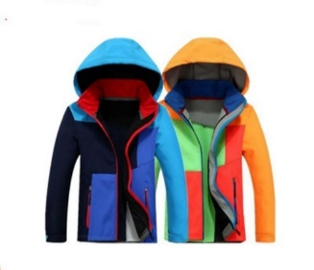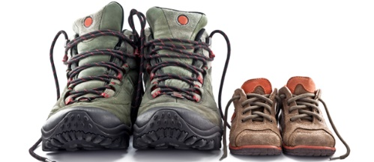

What to do before the session
Before the session begins the daily risk assessment will be carried out by the lead.
All equipment and tools will be checked.
Ensure all Staffing and volunteers/helpers are present and signed in for the session on the daily register as well as signed into school. If there are issues with staffing Sara Star will be informed as soon as possible.
The lead will ensure the register and any other relevant paperwork needed is collected and taken over with the group to the site.
During extremely hot weather children will be monitored and will be encouraged to have plenty to drink and will be sat down in the shade for periods of time. Please refer to the school sun policy which is filed in the school office for more information.
Clothing
Unless the weather is unsafe, Woodland Wanderers will run. Children arrive at school in their outdoor clothing, which should consist of the following: -
- Old Trousers (e.g. jeans)
- Long sleeved top/jumper
- Wellies/Walking boots/sturdy shoes
- A waterproof coat
NO JEWELLERY SHOULD BE WORN FOR SAFTEY
Depending on the season/weather children will also need to bring the following which may be required: -
- Hat/scarf/gloves
- Fleece/jumper
- Sun hat and sun cream. Sun cream must be applied by the child themselves.
Children also need to bring a change of clean clothes with them, including underwear, so they can change if need be.

Created by Sfarish December 2022 To be reviewed annually Last amended on 06/12/2022
Woodland Wanderers session plan
The aim of these sessions are to encourage children to interact with their environment and give them the opportunity to learn through real experiences whilst participating in child-led play. The overarching aim is to provide open ended opportunities for the children to thrive and enhance their holistic development. whilst promoting resilience, confidence, independence and creativity. Individuals will therefore increase self-esteem, empathy, social skills, problem solving and reflection to name but a few.
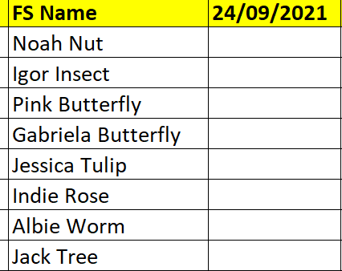
Our agreements:
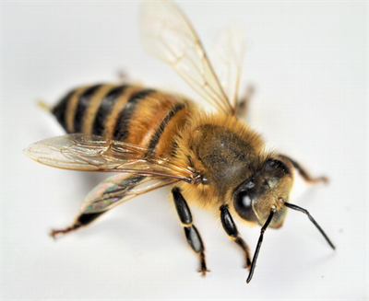 Kind Gentle Respectful Awesome
Reminders of safety (Children recite these once they are known) – 3 points of contact when climbing a tress, pallets must not be left standing up alone and must be supported so they are stable, Nuts, berries and mushroom – do not touch or put them in your mouth. If touched by accident wash your hands.

Registration using Woodland Wanderer names.
Children are given the session to choose what they would like to do. CHILD-LED PLAY.
Activities are available if they interest them include
Pens/pencils/charcoal etc.  Wool for weaving, making god’s eyes, 
Bug hunting equipment etc. 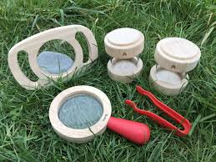 Mirrors for mirror walks
Sticks for building dens etc. 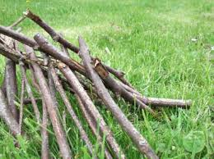 Making habitats for birds and animals 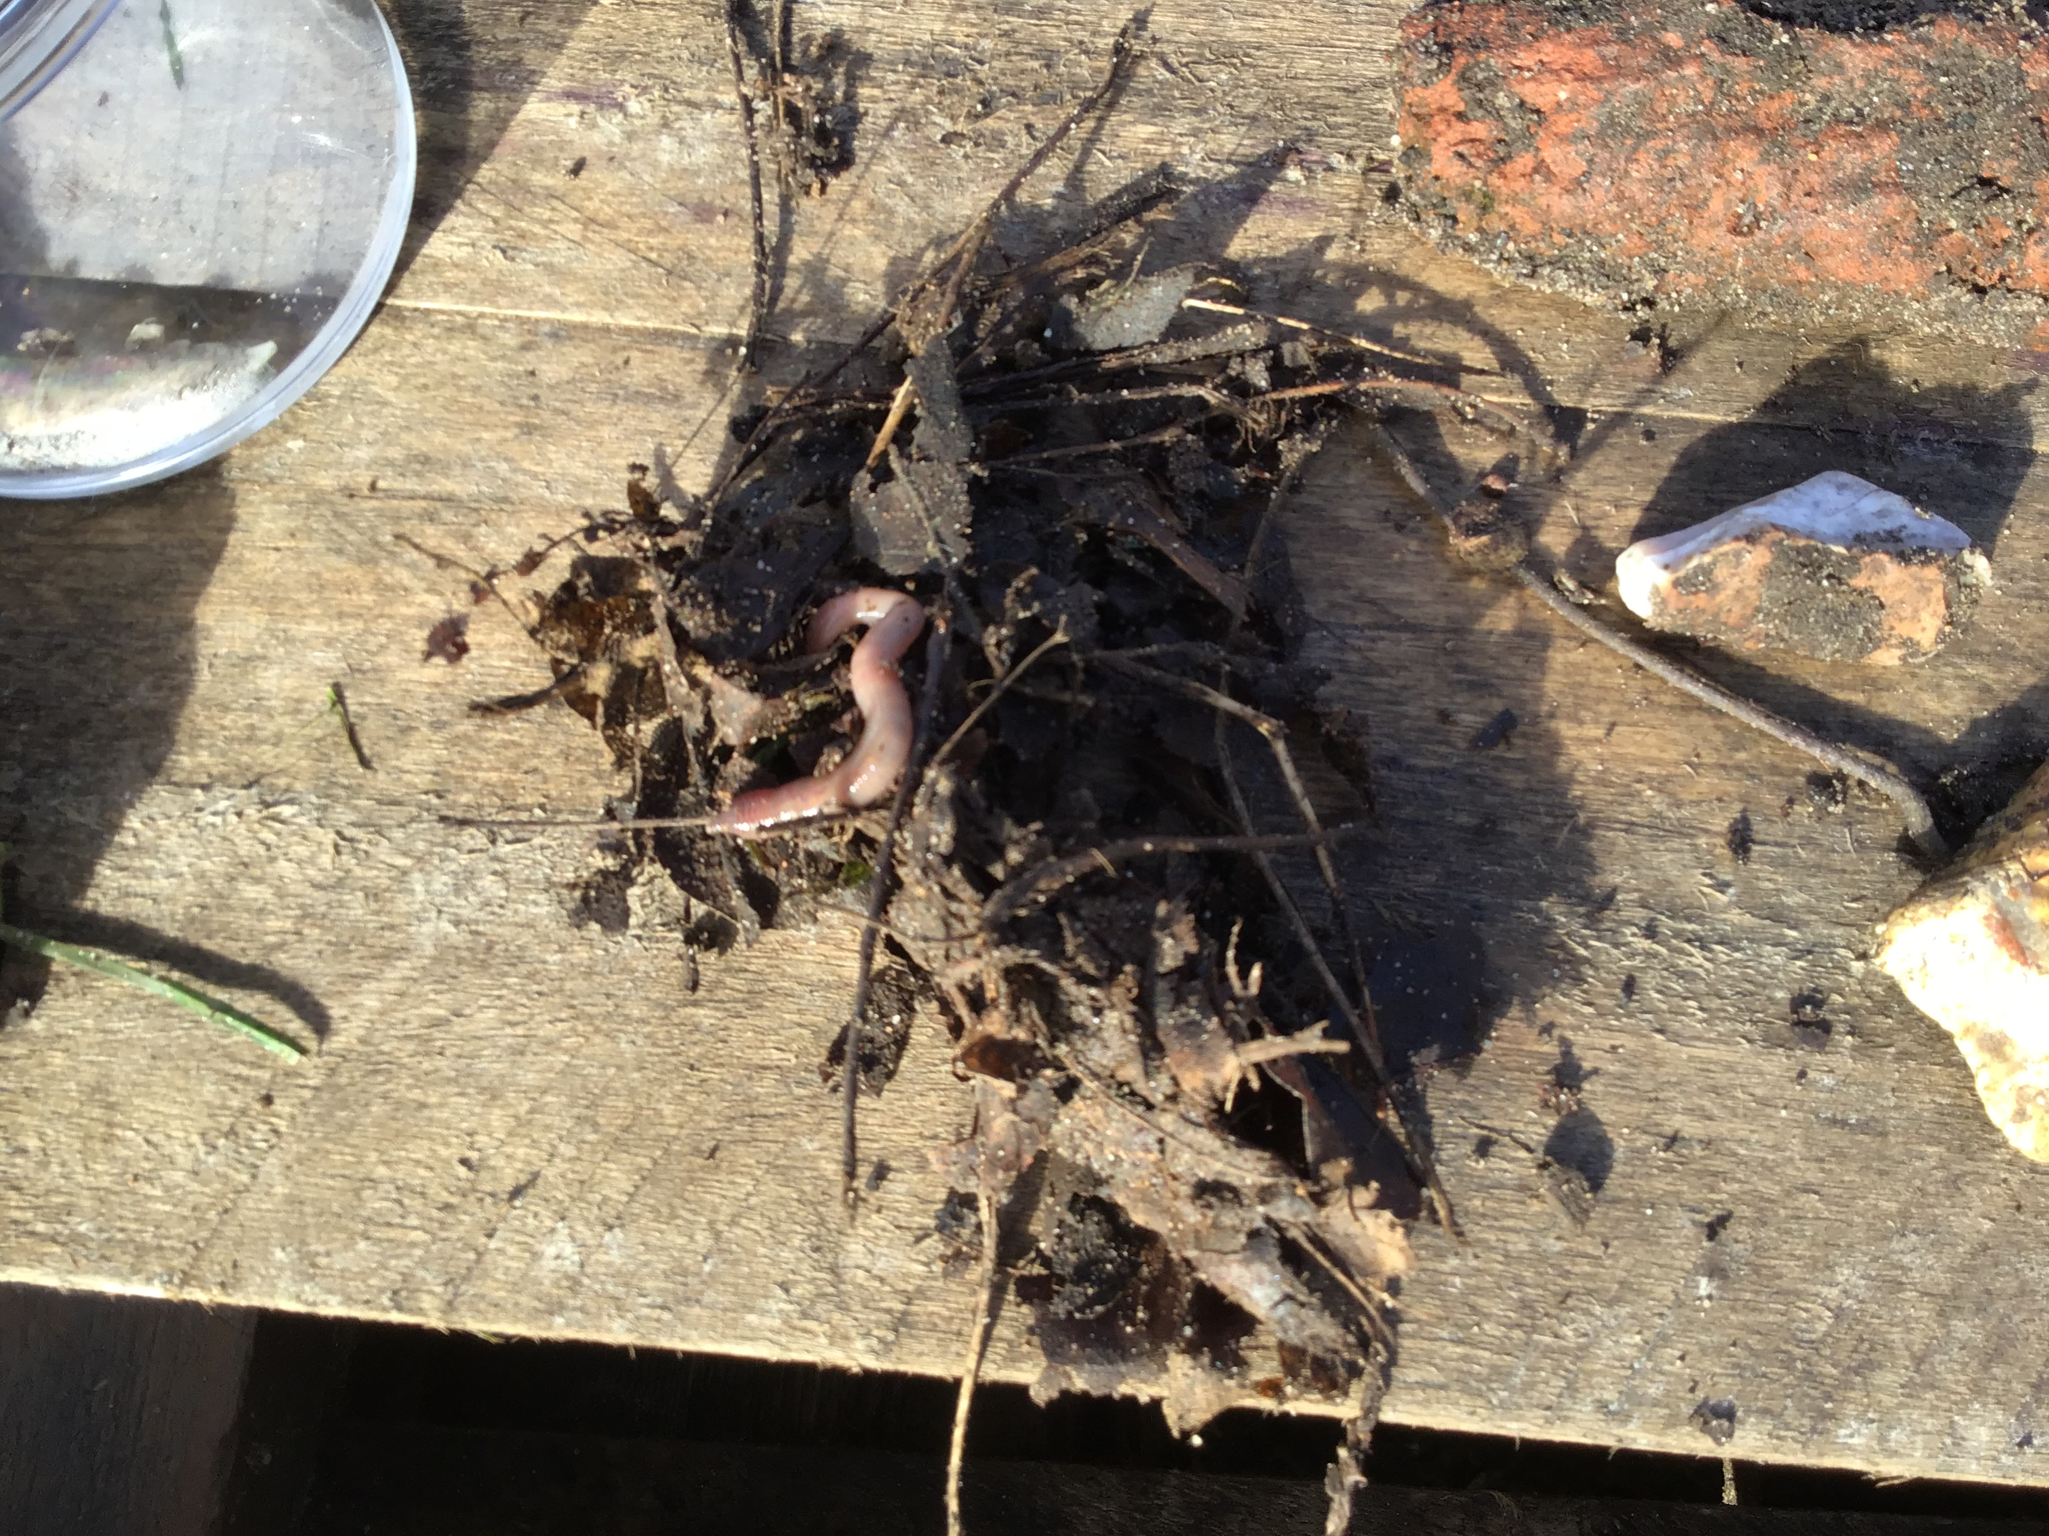
Tool use 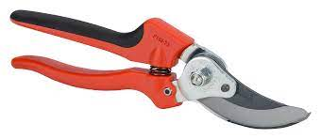 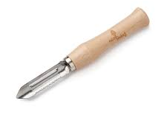 To name but a few……..

Created by Sfarish December 2022 To be reviewed annually Last amended on 06/12/2022
Talking time using a talking stick: Each child Has the opportunity to share what they have enjoyed doing or show us what they have found/made etc.
Note: All children know they do not have to share anything if they don’t want to and can simply pass the stick to the next person.
Children are also given the opportunity to make any requests of things they would like to do at their next session in order to meet the children’s interests. However, there are sessions when children are happy to continue playing their games from a previous session so there may be no requests. If there are they are noted in the reflection box on the session plan.
Sit spot at the end of the session so the children can learn to relax and enjoy some quiet time to themselves. This is to promote the children’s well-being and an opportunity to enjoy the natural environment around them – the sounds rustling trees, flying insects), smells (fresh cut grass, flowers) and touch (wind/sun on their face).
Note: Children who have been coming to Woodland Wanderers will also ask if we can do a sit spot as they enjoy this time.
What to do during the session
Throughout the session, the adults will be responsible for carrying out ongoing risk assessments to ensure nothing dangerous is being carried out. They will also be continuously head counting to ensure all children remain within the site and do not leave without permission from a school member of staff.

What to do at the end of the session
Before leaving the site a head count will again be carried out by the lead. All tools will be counted, checked, and placed back in storage. Once the children have been returned to class, the adults will feedback on how the session went and anything that needs addressing or changing etc.

Created by Sfarish December 2022 To be reviewed annually Last amended on 06/12/2022
Daily Safety Check List Woodland Wanderers
Date - | F/S practitioner:
Weather - | Signature:
Hazard | Checked | Action Taken
Canopy Layer/ Shrub Layer - deadwood in trees and fallen/loose branches
Ground Layer - Litter, uneven ground, Brambles, Stinging Nettles, animal faeces
Slippery Areas and standing water - excessive mud, Icy patches
Fire site - Fire pit cleared of debris and area safe for children to enter,
Boundary - Fencing is secure and not broken or damaged
Field Layer - Eye level branches, Poisonous plants, thorns, fungi etc.
Vandalism - evidence of intruders
Spare clothes - CHILDREN BRING TO SCHOOL
Any other hazards
Created by Sfarish December 2022 To be reviewed annually
Last amended on 06/12/2022
 | 

Our school safeguarding policy is filed in the school office and is adhered to at all times. If you have any concerns about a child these must be passed on to the lead that day, and reported immediately using CPOMS (a computer programme used by school to report safeguarding concerns). The completion of this should be by the adult who witnessed and or was disclosed. CPOMS is on my iPad and can be accessed from the school grounds. If it is a matter of urgency then the staff member who was disclosed to will be asked to return to the school immediately in order to report this. If we are unsure about anything or need another adult to be able to release, the person who has been disclosed to, then we will contact the office.
Safeguarding children at Woodland Wanderers
Laurence Hughes headofschool@wicklewood.norfolk.sch.uk
Megan Stuart senco@wicklewood.norfolk.sch.uk
Frances Thaker fthacker@wicklewoodschool.co.uk
Rachael Wolstenholme rwolstenholme@wicklewood.norfolk.sch.uk

This policy will also inform you of the accusation process and again anything of the sort needs to be reported to management will be made aware as soon as it is possible. Any required forms can be found in the staffroom.

Created by Sfarish December 2022 To be reviewed annually Last amended on 06/12/2022

Contact numbers if needed:-
If CADS (Children’s Advice & Duty Service) need to be contacted you can contact them on 0344 800 821.

Norfolk County Children’s services can be contacted on 0344 800 8020

LADO ( for allegations against adults working/volunteering with children) can be contacted on 01603 223 473

These contact numbers are displayed on our safeguarding board situated in the staffroom above the photocopier.

Staff are regularly updated with any changes to the policy and safeguarding training is refreshed every year for all staff.

Created by Sfarish December 2022 To be reviewed annually Last amended on 06/12/2022

Appendix 1: Draft Recording Form for Safeguarding Concerns

Staff, volunteers and regular visitors are required to complete this form and pass it to [ENTER NAME OF DSL] if they have a safeguarding concern about a child in our school.

Full name of child | Date of Birth | Class/Tutor/Form group | Your name and position in school

Nature of concern/disclosure
Please include where you were when the child made a disclosure, what you saw, who else was there, what did the child say or do and what you said.

Time & date of incident:

Who are you passing this information to?
Name:

Position:

[Ensure that if there is an injury this is recorded (size and shape) and a body map is completed]
[Make it clear if you have a raised a concern about a similar issue previously]

Your signature:

Time form completed:
Date:

Created by Sfarish December 2022 To be reviewed annually Last amended on 06/12/2022

Body Map

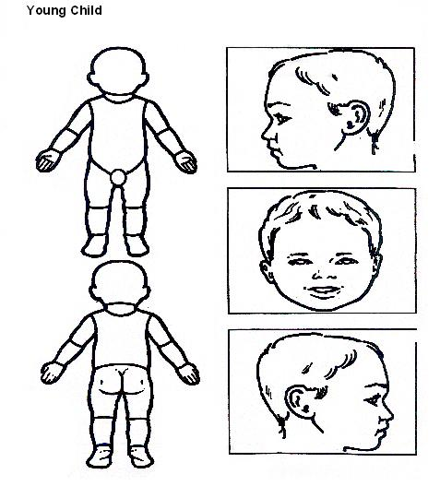

Indicate clearly where the injury was seen and attach this to the Recording Form

Created by Sfarish December 2022 To be reviewed annually Last amended on 06/12/2022

Confidentiality Procedure
All information given regarding the children will remain confidential and staff will be told on a need to know basis. Any paperwork will be filed in the relevant folder and kept in a secure lockable cupboard. Photos and videos of children will remain on the school server and will not be shared or used outside of school without the appropriate authorisation for those children’s parents prior to doing so.

Complaint Procedure
The school complaints procedure will be adhered to in this instant. If a member of staff is approached about a complaint, then this should be referred to the lead who will inform management and discuss the best way forward, whether it be a phone call, meeting etc. There are times when the PLO (Parent Liaison officer) will contact the parent themselves to discuss the issue. If the parent/carer wants to make it an official complaint the necessary paperwork needs to be submitted.

DBS Checks
All adults need to be DBS checked to ensure suitability of volunteers. LSA’s/TAs will already have obtained their DBS. DBS checked are filled in with the support of a member of the office staff. Once they have been sent off volunteers can begin to assist, however they must not be left alone with a child or take children to the toilet.

Created by Sfarish December 2022 To be reviewed annually Last amended on 06/12/2022

Equality within Woodland Wanderers

All pupils will be given the opportunity to participate in all Woodland Wanderers Activities regardless of age, ability or gender.
This programme promotes children's right to be strong/resilient and to be listened to. Pupils will be encouraged to develop a sense of autonomy and independence.
- All pupils will be respected and their individuality and potential recognised, valued and nurtured. The activities and the use of the provided equipment will offer pupils the opportunity to develop in an environment free from prejudice and discrimination.
- Pupils with exceptional needs will be admitted to the programme after consultation between teachers, parents (where appropriate) and practitioners. The programme will recognise the wide range needs of pupils and consider what part we can play in meeting these.
- All pupils should be adequately dressed to ensure that they are able to take part in all activities. A list of required clothing will be sent to parents/carers and these clothes can be kept in school.
- Appropriately sized personal protective equipment e.g. work gloves will be available for all participants.

Created by Sfarish December 2022 To be reviewed annually Last amended on 06/12/2022
Behaviour Policy and Procedure
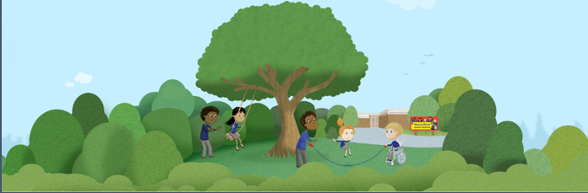
Everyone, including staff, volunteers and participants, have a responsibility to protect their own and other group members' health, safety and well-being. They should inform staff if anybody's actions are likely to jeopardise the safety or comfort of others. We aim to promote:
• Self-esteem
• Self-awareness of personal abilities and limitations
• Respect and care for oneself, other people and the natural environment
• Co-operation and non-violent communication.
Our agreements and Ground Rules will be made between the staff and all children at the start of their first session. This will include items such as respecting oneself, each other and the environment and listening carefully to instructions when they are given. The group will be encouraged to contribute to the agreements before it is ‘sealed’. Ground rules are firmer non-negotiable rules, such as ‘no violence’ and will be explained along with the consequences of breaking them i.e. 2 rule reminders, then removal if dangerous behaviour continues.
We will work with each group to develop a clear set of boundaries and guidelines. Each child will have the opportunity to voice their own feelings. Talking about how they wish to be treated and listening to the feelings of others is important as it will allow the group to work together, understand one another and ultimately become more supportive and cooperative. It will also contribute to making the Woodland Wanderers a safe and enjoyable space. De-escalation If a situation arises where children are behaving in a way that threatens the safety of the group, the lead will call an emergency circle time and encourage discussion of new strategies and possible agreements so similar situations don’t arise in the future. In all these cases, the lead will complete an incident report form, and where necessary inform the child’s teacher as well as the parents/carers. If behaviour is deemed dangerous, it is the leader’s responsibility to deal with this appropriately. In some cases, it may be necessary for children to have ‘time out’ or leave the session early. Any decision to remove a child should be carefully considered alongside the benefits of the outdoor provision.
Positive behaviour management strategies used in school will also be used. Please refer to the behaviour management policy in the school office for further detail. Children will be reminded about school rules with regard to how they treat other children/adults. Children who are new to the site will establish their own set of ‘agreements’ (with guidance from the leader). These may include - How to look after each other/equipment/flora and fauna, boundaries etc.

Created by Sfarish December 2022 To be reviewed annually Last amended on 06/12/2022
Should bullying occur it will be dealt with in the same way as school would deal with i.e. It will be recorded onto an incident form and logged on pupil asset. The children’s teacher will be informed and depending on the child’s current score within our behaviour pathway depends on the next course of action.

Behaviour expectations for leaders, assistants and visitors: -
● Be a positive role model for participants, particularly with regards to respecting each other and the environment.
● Encourage and reinforce caring and nurturing behaviour.
● Be vigilant with regards to common sense safety.

Created by Sfarish December 2022 To be reviewed annually Last amended on 06/12/2022

