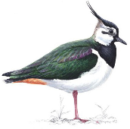
Lapwing Class Home Learning
19th September 2023

Essential Skills

- Reading
- Times Tables
- Spellings

Reading
Please continue to read at home this week. We are aiming for a goal of having everyone in Lapwing reading at least 5 times each week!

Library books can be exchanged when read, although is not expected that a child will finish reading their library book every week, particularly if they have chosen a challenging or longer text.

Reading at home should be recorded in reading records, which can be brought into school everyday as children will be heard read throughout the week and we need to record that in their reading records. We have ordered new reading records and each child will get one when they arrive.

Times Tables
Please practice Times table rockstars this week. Children should have a gig to complete this week.
In class we will be practicing our times tables regularly but the more the children practice their times tables the more confident they will become.

If you do not have access to TTRS please let me know and I can provide log in details or alternative options.

Spellings
This week we have been looking at spelling a range of words that use the prefix ‘in-’ meaning ‘not’.

Please find on the home learning page, this week’s spellings to practise at home. There will be a short test of these spellings next Thursday.
Please encourage your children to practice their spellings every day.

This week’s spelling words are:
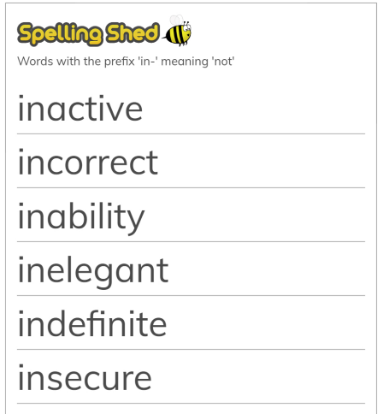
Added Extras

Music
In music this week we have been learning about Brazil and had a special visit from one of our wonderful parents.
This week, why not have a go at writing down as many facts about Brazil as you can remember.

Science
In science next week, we will be doing a practical experiment to find out how states of matter change when they are heated and cooled. Why not have a go at writing a prediction as to what you think will happen when syrup is put in the freezer and skittles are heated up.

