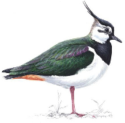
Lapwing Class Home Learning
14th September 2023

Essential Skills

- Reading
- Times Tables
- Spellings

Reading
Please continue to read at home this week. We are aiming for a goal of having everyone in Lapwing reading at least 5 times each week!

Library books can be exchanged when read, although is not expected that a child will finish reading their library book every week, particularly if they have chosen a challenging or longer text.

Reading at home should be recorded in reading records, which can be brought into school everyday as children will be heard read throughout the week and we need to record that in their reading records. We have ordered new reading records and each child will get one when they arrive.

Times Tables
Please practice Times table rockstars this week. Children should have a gig to complete this week.
In class we will be practicing our times tables regularly but the more the children practice their times tables the more confident they will become.

If you do not have access to TTRS please let me know and I can provide log in details or alternative options.

Spellings
This week we have been looking at spelling a range of words that are homophones or almost homophones.

Please find on the home learning page, this week’s spellings to practise at home. There will be a short test of these spellings next Thursday.
Please encourage your children to practice their spellings every day.

This week’s spelling words are:
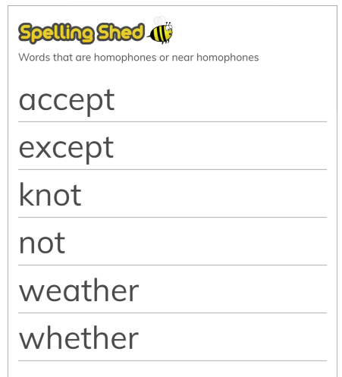

Added Extras

English
This week we have been looking at illustrations by Liz Pichon in Art.
Liz is running a short story competition and I’d like to encourage as many children as possible from Lapwing Class to have a go at writing a story and I can send them off to the competition if you write a note with their work saying you give consent for them to be entered.
The details from the competition are below:

Celebrate Tom Gates: Five Star Stories (Hooray), we are launching the first ever Tom Gates funny story competition (hooray!) with Liz Pichon.
The funniest FIVE STAR story will feature in the paperback edition of Tom Gates: Five Star Stories (Hooray) and be illustrated by Liz Pichon!

The winning writer will also receive a Tom Gates goody bag and signed books. Five runners up will win signed books.

In the new book, Tom and his friends are challenged to write a funny story by their teacher Mr Fullerman.

We are asking YOU to write a funny short story of no more than 350 words or 1 x page of A4 paper.

Here are TIPS to get you started:

Write about something that’s made you laugh or that you find fun.
Read it out loud when you finish writing it.
Why not try adding doodles?
You could also write a funny poem too.
Now – what are you waiting for? Get writing and MAKE US LAUGH!

Liz Pichon and the Tom Gates team will judge the winners.

How to enter
Simply ask your parent, teacher or guardian to send a photo or scan of your story to tomgatescomp@scholastic.co.uk by 11.59pm on November 16, 2023 for a chance to win. The competition is open to children aged 14 and under from the UK and Ireland. One entry per child. Entries must be submitted by a parent/guardian/teacher. Entrants consent to the child’s story, first name, age and county being published by First News and Scholastic. Only the winner and runners up will be contacted. Full terms and conditions apply: go to scholastic.co.uk/competition-terms

Art
As part of our art this term we are looking at telling stories with pictures. Why not have a go at drawing some illustrations for a few pages of your favourite book.

