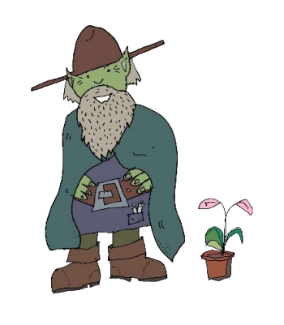
Cave Elves – Friends or Foe?
Why is it that cave elves have interested elf whisperers over the years? Perhaps it is because the cave elf is such an intriguing, rare form of elf and little is known about it.
Nocturnal Creatures
Generally, cave elves are nocturnal (only active at night) because they have grown so used to living in deep, dark caves. Worryingly, if these sensitive creatures come into direct contact with sunlight, it is so bright and hot that they can hardly see. A word of warning – do not handle cave elves as they may lash out in defence if they cannot see!
Appearance
Typically, cave elves are easy to identify as they are the smallest elf in the world being about the size of small cats. They wear broad-brimmed hats to keep the sun from their faces and leather clothes. Because of the need to be camouflaged, the adult cave elf is a dark green colour which enables it to hide in shadows as well as trees, hedgerows, and tall grass. Additionally, these intriguing beings often wear cloaks, sturdy boots and have long beards and pointed ears. However, juveniles are born with a yellowish tinge and red hair which they lose after their 100th birthday. Unfortunately, their young – which are often mistaken for rats – are commonly treated as pests by humans.
Where do cave elves live?
Cave elves reside in most mountain ranges and hills where there are plenty of hiding holes. Although a minority of elves live as hermits (alone), most cave elves prefer to live in large groups in underground caverns where they feel safest. A group of cave elves is known as a drove. When out and about foraging for food in their habitat, these endangered species will keep to the shadows and this makes them very difficult to identify. In addition to this, they live in harmony with and train mice as their pets. The mice – which are often given names by the eves- are treated in the same way that humans fuss over dogs or cats.
Diet
These shy and gentle creatures, which are herbivores, grow their own fruit and vegetables on mountainsides close to the entrance to their dens. When supplies are low, they may venture further and gather food such as wild berries, fungi and edible flowers to add to their diet. Our advice is that to preserve these mysterious and gentle creatures, all elf lovers living near caves should make sure that vegetable and fruit peelings are left out during snowy weather.
Harmless Hobbies
Whilst most elves are renowned for their magical abilities and precious stones, the cave elf shows no interest in gold, silver or any other valuable stones. They are only interested in playing chess and wiling away their time holding quiz shows and tending to their indoor pot plants. Furthermore, these nocturnal creatures can spend up twelve hours a day sleeping.
The future of the Cave Elf
Shockingly, these delightful creatures have been mistaken for other less pleasant types of elves and are therefore being hunted. In fact, cave elves present no danger to humans, and several have made friends with shepherds who are often out at night tending to their flocks. Our ‘save the cave elf’ campaign has been working tirelessly for several years to protect these unique beings as they could be at risk of extinction. Animal conservationist - David Battenburg -suggests that where their cave dwellings and caverns have been discovered, humans must ensure that the location is kept secret.

