

Wicklewood Primary School

Forest School Handbook
2025 – 2026

‘Our School and curriculum empower pupils and staff to be advocates and agents of change for a more sustainable world’
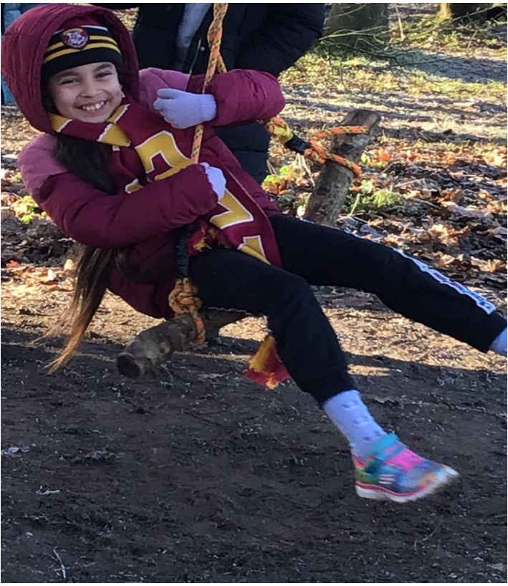

Created by Sfarish 3rd September 2025 To be reviewed annually Last amended on 03/09/2025
Contents Page

Page Number | Contents
1 | Front Cover
2 | Contents Page
3 | Contents Page
4 | What is Forest School
5 | What is Forest School continued
6 | Operating Forest Schools whilst minimising the impact and maintaining sustainability
7 | Operating Forest Schools whilst minimising the impact and maintaining sustainability continued
8 | Forest School Health and Safety – Ratios, risk management/assessment procedure,
9 | First Aider procedure, Procedure If FS Leader unwell or injured
10 | First Aider list, Accident & Emergency procedure,
11 | Lost or missing child procedure
12 | Weather Policy
13 | Toileting/Hygiene Procedures, Record/Filing of parent/carer consent Inc. medical consent, Record/Filing of parental/carer permission for photos, insurance,
14 | Tools procedure
15 | Secateurs Procedure
16 | Peelers Procedure
17 | Tree Climbing procedure
18 | How to climb a tree safely
19 | Fire Policy and Procedure
20 | Fire Policy and Procedure continued
21 | Bow Saw Procedure
22 | Bow Saw Procedure continued
23 | Knife Procedure
24 | Palm Drill Procedure
25 | Rope Swing Procedure
26 | Hammer and nails procedure
27 | Hammer and nails procedure continued
28 | Food Hygiene Procedure
29 | Daily Operating Procedure – what to do before the session, clothing
30 | Forest schools session plan
31 | Forest schools session plan continued
32 | What to do during the session, What to do at the end of the session
33 | Daily Safety Checklist
34 | Safeguarding children at Forest School
35 | Safeguarding children at Forest School continued
36 | Safeguarding children at Forest School continued
37 | Safeguarding children at Forest School continued
38 | Safeguarding children at Forest School continued
39 | Confidentiality procedure, complaints procedure, DBS check
40 | Equality within Forest School
41 | Relationship Policy
42 | Relationship Policy continued
43 | Information for supporting staff and parents
44 | Information for supporting staff and parents – What is Forest Schools
45 | Information for supporting staff and parents – Play Cycle
46 | Information for supporting staff and parents – Play Cycle
47 | Information for supporting staff and parents – Play Cycle
48 | Information for supporting staff and parents – Who runs Forest School
49 | Information for Assistants
50
51

What is Forest School?

The Forest School Ethos at Wicklewood

Forest School is a unique educational experience that helps children develop confidence, resilience, and self-esteem through hands-on learning in a woodland environment. It provides opportunities for children to engage in motivating and achievable activities throughout the year, in almost all weather conditions.
At Forest School, children learn by exploring, playing, and working with tools in a safe, structured way. They develop an understanding of boundaries—both social and physical—while growing in independence, problem-solving skills, and respect for the natural world.
The Forest School approach originates from Denmark, where it was first offered to preschool children. Research showed that children who attended Forest School entered formal schooling with strong social and communication skills, the ability to collaborate effectively, high self-esteem, and confidence in their own abilities. These qualities laid the foundations for greater academic achievement.
At Wicklewood Primary, we are proud to provide Forest School sessions for select children from Reception through to Year 6. These experiences enrich and extend the curriculum, offering children valuable opportunities to learn beyond the classroom.

Principles of our Forest School
Forest School is a specialised approach to learning that complements and enriches outdoor and woodland education. Its principles are shared by thousands of trained practitioners across Norfolk, the UK, and beyond.
At Wicklewood, our Forest School is:

- A long-term process of regular sessions, rather than one-off or infrequent visits; the cycle of planning, observation, adaptation and review links each session.
- Takes place in a woodland or natural environment to support the development of a relationship between the learner and the natural world.
- Uses a range of learner-centred processes to create a community for being, development and learning.
- Aims to promote the holistic development of all those involved, fostering resilient, confident, independent and creative learners.
- Offers learners the opportunity to take supported risks appropriate to the environment and to themselves.
- Run by qualified Forest School practitioners who continuously maintain and develop their professional practice.

Children who take part in Forest School are seen as

- Equal, unique and valuable
- Competent to explore and discover
- Entitled to experience appropriate risk and challenge
- Entitled to choose, and to initiate and drive their own learning and development
- Entitled to experience regular success
- Entitled to develop positive relationships with themselves and other people
- Entitled to develop a strong, positive relationship with their natural world.

Forest School is an inspirational process that offers ALL learners regular opportunities to achieve and develop confidence and self-esteem through hands-on learning experiences in a woodland or natural environment with trees. At Wicklewood we

- Develop personal and social skills
- Work through practical problems and challenges
- Use tools to create, build or manage
- Discover how they learn best
- Pursue knowledge that interests them
- Learn how to manage failures
- Build confidence in decision making and evaluating risk
- Develop practical skills
- Understand the benefits of a balanced and healthy lifestyle
- Explore connections between humans, wildlife and the earth
- Regularly experience achievement and success
- Reflect on learning and experiences
- Develop their language and communication skills
- Improve physical motor skills
- Become more motivated
- Improve their concentration skills

Operating Forest schools whilst minimising the impact and maintaining sustainability

Potential Environmental Impacts
- Trampled vegetation – Regular footfall from children and staff can destroy the ground layer, preventing plant regeneration and reducing biodiversity.
- Loss of habitats – Removing dead wood for fires and activities can harm fungi, insects, and other woodland creatures that rely on decaying matter.
- Soil degradation – Ground fires alter soil chemistry, increasing pH levels and reducing essential nutrients, which affect plant health.
- Tree damage – Climbing, shelter building, and swings can weaken or damage trees over time.
- Damage to the canopy layer – birds nests etc at risk due to potential smoke from fires.
- Overharvesting – Picking leaves, flowers, or plants reduces natural regeneration and food sources for wildlife.
- Overuse of areas – Concentrated activities in particular areas can lead to long-term ecosystem decline.

Strategies for Minimising Impact
- Potential for zoning & rotation of areas being used.
- Divide the woodland into sections and rotate activities to give areas time to recover.
- Designated paths & activity zones.
- Fires only to be lit when needed so not a daily activity.
- Use raised fire pits instead of ground fires to prevent soil damage.
- Limit firewood collection to fallen twigs from outside the core area or bring in wood from sustainable sources and ensure the correct wood is used to reduce smoke.
- Use tree-friendly ropes and padding for swings.
- Rotate climbing trees and avoid using the same ones repeatedly.
- Leave dead wood, leaf litter, and fungi undisturbed wherever possible.
- Provide bug hotels or log piles as alternatives for minibeast habitats. Teach children about respecting nature (e.g., “look, don’t pick”).
- Encourage observation, photography, and journaling instead of collecting natural items.
- Adults sharing their knowledge and skills with the children to upskill them. For example why insects are so important - They aerate the soil, pollinate blossoms, and control insect and plant pests, and feed on dead animals and fallen trees enabling the recycling of nutrients back into the soil. As decomposers, insects help create topsoil, the nutrient-rich layer of soil that helps plants grow. Bugs that burrow, such as ants and beetles, dig tunnels that provide channels for water, benefiting plants. Bees, wasps, butterflies, and ants pollinate flowering plants.
- Water for water/mud play is collected rain water instead of tap water.

Monitoring & review
- Regularly assess the condition of the woodland and adapt activities to reduce impact.
- Involve children in sustainability projects such as planting, habitat creation, or litter removal.

Forest schools can thrive sustainably when activities are carefully managed. By balancing play and learning with conservation practices, we protect biodiversity while allowing children to connect meaningfully with nature.

Forest School Health and Safety
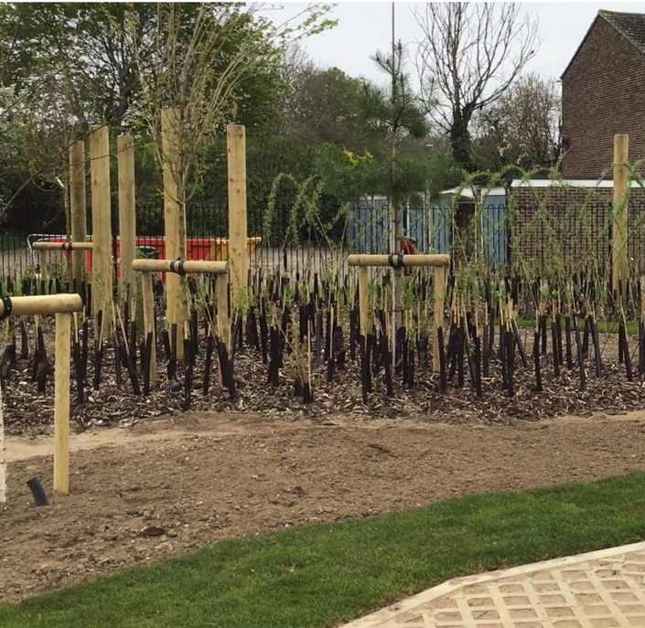
Staffing and Ratios
Sessions will be run by a Forest School qualified member of staff, Ms Farish (level3). A classroom TA/LSA will also be attending and a volunteer. If, In the unlikely event, I am unable to replace the volunteer or TA due to sickness absence then the whole class will go out in the morning or afternoon for their session with the class teacher, myself and the TA or volunteer (depending who is absent). This session will then be run as an outdoor learning session as opposed to Forest School (namely Woodland wanderers). If both the TA and volunteer are ill the session will be cancelled and rescheduled for another time if possible. If the forest school leader is absent then the forest school sessions for that day will be cancelled.

Risk Management and Assessments Procedure
The Forest School Leader is responsible for the risk assessments. There is a termly risk assessment and Risk/benefit assessments will also be completed for activities such as tool use and fires. Risk/benefit assessments for individual children will be carried out as necessary. As part of the risk assessment process the risk benefit also needs to be considered. This is analysing each activity and deciding whether the benefits to the children’s learning outweighs the risk involved. A certain level of risk in our lives is accepted as necessary to achieve certain goals.
Please see current risk assessments, others will be added as activities are implemented.

First Aid Procedure
- The leader has an outdoor first aid qualification which will be kept up to date.
- A first aid kit along with a burns kit will be kept in the storage container within the forest school area. Additional first aid kits are within the school building.
- School first aid policies and procedures will be followed in the event of an accident and these can also be found in the school office. The first aid procedure for in school is as follows:- https://docs.google.com/document/d/1W9YzfwMX6DdM-GzIzBYlS5jCzqs-Nrjn/edit?usp=drive_link&ouid=109118390532562717214&rtpof=true&sd=true
In the event of an accident resulting in injury:
- The closest member of staff present will assess the seriousness of the injury and seek the assistance of a qualified first aider, who if appropriate, will provide the required first aid treatment
- The first aider, if called, will assess the injury and decide if further assistance is needed from a colleague or the emergency services. They will remain on the scene until help arrives
- The first aider will also decide whether the injured person should be moved or placed in a recovery position
- If the first aider judges that a pupil is too unwell to remain in school, parents will be contacted and asked to collect their child. Upon their arrival, the first aider will recommend next steps to the parents
- If emergency services are called, a member of staff will contact parents immediately
- The relevant member of staff will complete an accident report on the same day or as soon as is reasonably practical after an incident resulting in an injury
There will be at least 1 person who has a current paediatric first aid (PFA) certificate on the premises at all times.
- All accidents are recorded in an accident logbook. A copy of this is sent home with the child. Parents will be contacted for those children who suffer a head or joint injury.
- All staff will be made aware of any medical conditions of the children. Inhalers, epi pens etc. will be left in the school building unless specifically required for those children with severe medical needs.
- Contact details and medical details are stored on Arbor, which all staff have access to. A volunteer would not be expected to contact parents. Parents are informed by a phone call home – if it is necessary.
If the Forest School Leader becomes unwell or has an accident
- If the Forest Schools lead becomes seriously unwell the TA will phone reception (there are 3 members of staff situated in the reception area to ensure they are always contactable). If for some reason they are uncontactable we have mobile numbers for Designated Safeguarding leads who have their phones on them at all times.
- Additional help will be sought (preferably another first aider from school to assist). Whilst doing this they will be staying with the Forest Schools leader to make sure they remain comfortable and perform appropriate first aid treatment if required.
- The volunteer (who is not necessarily first aid trained and will not have a mobile phone with them due to our safeguarding policy) will down tools and return the children back to class.
- If the Forest School lead has a serious accident i.e. trips and hurts their ankle, cuts themselves with a knife etc. the same procedure will apply, however, if an ambulance is required the TA will use our mobile phone whilst staying with the leader and the office staff will also be informed (by phone or the volunteer will inform them on returning to the school building). Any treatment to be given will be provided by a named first aider (see list below).

- Tanya Bush
- Jo Vincent
- Joy Clarke
- Sophie Oakley
- Hannah Samuel
- Francis Thacker
- Abi Knight
- Elise Morritt
- Karen Bush

This list is continuously updated)
Sara Farish Outdoor First aid &
Paediatric First aid 14/07/2023 14/07/2026 ITC First

Accident and Emergency Procedure
In the case of a serious accident or emergency of a child, the leader will remain with the injured party and phone immediately for an ambulance if one is needed. The office staff will be informed and a request made for another adult. The office will inform parents. All Contacts are accessible from the school office and/or Arbor. Our accident and emergency policy will be followed in line with the school and can be found in the school office.
Wicklewood Primary School
Orchard House
30 Hackford Rd
Wicklewood
Wymondham NR18 9QJ

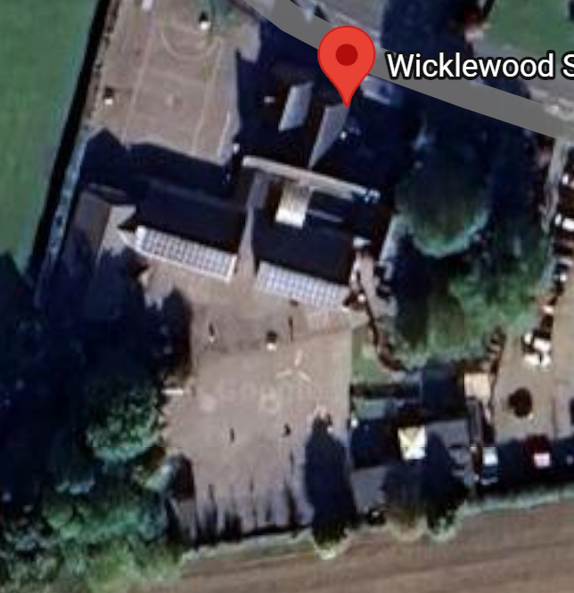
What 3words location: Fencing.Swimming.Career

Lost or missing child procedure
The Forest school site is within the school grounds so there is little risk of losing a child. The school premises are locked at all times so if a child chooses to run off they would not be able to leave unless they climbed over the fence. If this did occur the Forest School Leader will remain with the group of children and another adult would be asked to go and retrieve the child and if need be return them back to a member of management to deal with. See Critical incidents and trauma management procedure.

Weather Policy

Forest Schools is all about being outdoors in nature. We have a cabin and a sheltered fire area within our school site which gives us shelter and shade when it is needed. However, some weather conditions will affect the running of the sessions.

Staff will keep up to date with the weather forecast for each day, however sometimes decisions may be taken on the morning of the session if there is a sudden change to the weather.

Lightning
Lightning can be dangerous, especially in a woodland setting, as there is a risk of being hit by both directly and via tree roots.

High Winds
High winds can be dangerous due to falling branches, even trees, as well as loose debris being blown around. In exceptional circumstances, the Forest Schools lead may make the decision that it is not safe to be in the Forest Schools area.

As we are using our own school site we will return to the school building if there are any sudden weather changes (Lightning or very high winds).

Toileting and hygiene Procedure for Forest School site within school grounds
Children will be encouraged to visit the toilet before we leave the school building and enter the Forest school site. Children can visit the toilets if necessary during the session. They must get permission from a member of school staff and inform the same member of staff when they have returned. Some children may require an adult to take them and this will be the LSA. Washing hands is currently being carried out in the class so hot water can be used.
Record and Filing of Parental/Carer consent including medical consent
Parents/Carers are asked to give permission for their child to participate in the preparation, cooking and eating of food. This also gives parents the opportunity to inform us of any dietary requirements and allergies etc. Medical consent is required when the children enrol with the school and is held in the school office as well as input onto Arbor under the child’s profile. Children with medication will already have a medication consent form at school.
Record and filing of Parent/Carers permission for photos/Videos
Parent’s enrolment forms include a section giving permission for photos and videos to be taken. It will be the Forest School leader’s responsibility to check if this has been authorised by the parent/carer of those children attending Forest School. Permission for photos to be used in coursework if ever needed would however be a separate letter to be sent out for authorisation. Photos/videos are taken on school ipads and the photos are stored either on the staff server and/or on google drive – both of which are secure and can only be accessed by staff. Please see the code of conduct policy which can be found on the following link:
https://docs.google.com/document/d/1T_lGJU1cxAXLBMUwwwNL-1FCr1sAn_5r/edit?usp=drive_link&ouid=109118390532562717214&rtpof=true&sd=true
Insurance
Public liability insurance is with Zurich Municipal via Norfolk County Council
1st April 2025 to 31st March 2026
Steve Rayner - Head of Insurance
Ground Floor
County Hall Annexe
Martineay Lane
Norwich
NR1 2UE

Tool Use Procedure
Children and adults will be trained in the use of each tool before they use it by the leader. Tools will be counted in and out. Tools will be stored safely and kept out of the reach of children. They will be cleaned after each use to prolong their life, broken and damaged tools will not be used. Children and adults will be informed of rules and safety before they use them.
Tools will be used on a ratio of 1 adult to 2 children.
Tool procedures and risk/benefit assessment will be added as necessary.

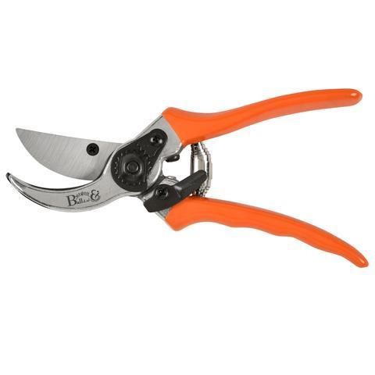
Secateurs Procedure –
For cutting twigs smaller than a penny piece than penny.
Skills supported Improved fine and gross motor skills, spatial awareness.

How to use it safely

• No gloves on tool hand; well-fitting glove on non-tool hand. Gloves need to be a really good fit otherwise grip on the working material can be compromised.

• Maintain a safe distance. Always use tools at a distance at arms’ length and one tool’s length away from other people – Blood Bubble.

• Establish expected behaviour. : To ensure everyone clearly understands all instructions and expected behaviour for safe tool use. Anyone misusing a tool intentionally will be required to put down the tool, and step away, until they are ready to behave appropriately and join in again.

• Ensure proper demonstration and supervision.

• Ensure the secateurs are used correctly so they are smiling (As above picture).

• If it is a long stick, ask a friend to help you hold it.

• To put down, close and lock safety catch and return to the designated place.

Passing Holding blades in gloved hand, offer handle to person.

Placing Always return it to its designated place when not in use.

Cleaning Use cloth and WD40 to ensure all dirt and moisture is off the blade.

Storing Store in the Tool bag provided.
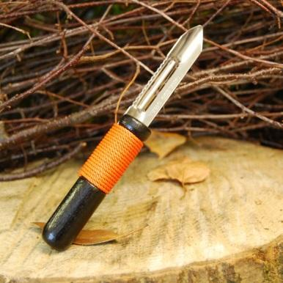
Peelers Procedure –
For whittling small soft stick sticks and peeling bark.
Skills supported Improved fine and gross motor skills, spatial awareness.

How to use it safely

• No gloves on tool hand; well-fitting glove on non-tool hand. Gloves need to be a really good fit otherwise grip on the working material can be compromised. It is better to have no glove and a safer grip than a glove that is too big.

• Maintain a safe distance. Always use tools at a distance at arms’ length and one tool’s length away from other people – Blood Bubble.

• Establish expected behaviour. : To ensure everyone clearly understands all instructions and expected behaviour for safe tool use. Anyone misusing a tool intentionally will be required to put down the tool, and step away, until they are ready to behave appropriately and join in again.

• Ensure proper demonstration and supervision.

• You must remain seated. Keep the blade facing away from you on the outside of your wood, on the outside leg peeling away from the body.

Passing Hold blades in gloved hand and offer handles to other person. Do not walk around with the peeler.

Placing Put the tool down on ground or surface with the handle facing backwards, or return it to its designated place.

Cleaning Use gloved hand to clear out any wood & dust in the blade of the peeler. Use cloth and WD40 to ensure all dirt and moisture is off the blade.

Storing Store in a tray in the storage container.
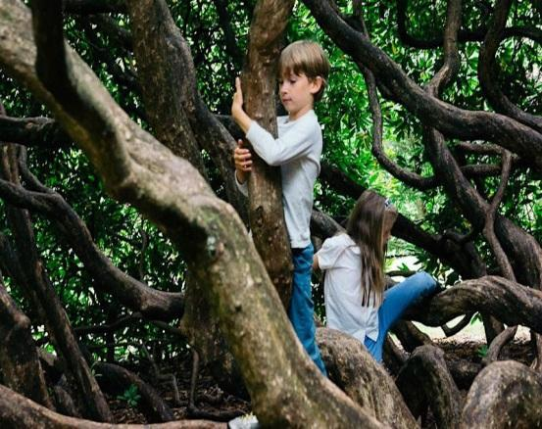
Tree Climbing Procedure –
For children to take a risk
Skills supported Improved gross motor skills, taking a risk, risk assessing.

Children will not be allowed to climb trees if:
- The trees are too slippery due to wet weather conditions.
- There is dead wood in the tree canopy above the climbing area.
- Their clothing is unsuitable including wearing jewellery- easily caught on tree branches or flimsy footwear.
- An adult is not within sight- an adult must be near the tree children are climbing.

Forest School offers children the opportunity to manage risk, therefore if a child wishes to climb a tree they need to do it independently.
An adult may show children where to put their feet and give verbal encouragement but they may not help children to climb.
If a child has climbed up the tree and panics, an adult will help them by pointing out step by step how to get themselves down. If a child is very distressed and cannot get down independently then an adult may lift them down taking care of their own back.
One child may climb up and down at a time and the rest of the group need to keep a safe distance.
If a child falls from a tree the Forest School Leader will administer first aid. Parents will always be informed as soon as possible to decide whether the child needs to go home.

How to climb a tree safely – As high as the mark on the tree

• Put your foot in the lowest foothold and your hand on a branch or handhold. Always have 3 points of contact when climbing i.e. 3 limbs should always be connected to a branch.

• Lift your weight a little bit before lifting your body up to test the handhold or branch strength.

• Pull your other foot up to a higher foothold and lift your body.

• Use your hands to establish a safe position on your chosen branch.

• Sit on the branch or stand up whilst always holding on- never let go.

• Face the tree to get down.

• Feel the foothold with your foot and put your weight on it when it feels safe.

• Continue putting one foot underneath the other until your feet hit the floor.

• Well done- you have climbed a tree!


Fire Procedure –
To understand its uses
IF FIRE AND ONLY 2 ADULTS NO TREE CLIMBING PERMITTED AND EXTENSION CLOSED OFF. Children to be seated round the fire circle.

Skills supported knowledge and understanding of fire as a tool.

Fire procedure
Fires are an important part of Forest School and will be used in sessions. We aim to ensure that all children and adults participating in Forest School sessions with fires will do so safely and with as little risk to their health as possible. We have established a fire area and train pupils how to approach and leave before lighting a fire:
Fire Circle Agreements
- We always walk when approaching the fire circle.
- We always go around the outside of the circle to get to the other side.
- We always stay seated when at the fire.
- We only enter the Fire Circle when instructed by the Forest School Leader.
- No loose clothing or loose hair in the Fire Circle.
Fire Safety procedures
During the Forest School process, a careful regard and respect of fire is reinforced with the children through a step by step process. Strict fire circle rules are enforced at all times and behaviour is controlled by the Forest School leader and support staff.
The fire Site has been carefully chosen. There are no hanging branches and tree roots have been avoided etc. Stones are not present in the fire area as hot stones (especially flints) can explode. A fire pit has been placed in the centre of the fire area. Our fire site is situated away from buildings and is in a fire shelter that has been specifically built. It is the decision of the forest school leader as to whether a fire is lit in certain conditions i.e. too windy.

Created by Sfarish on 20th July 2018. To be continually reviewed by FS Leader

A fire is never to be left unattended and we have a large container of water nearby to pour on the fire.
The forest school leader will explain to participants the importance of using only dead wood for fires. Smoke inhalation will be reduced by burning dead wood. Those in smoky areas will be encouraged to move to less smoky areas. Fires will only be lit in the fire pit.
All participants will follow the fire circle rules about how to behave and move around the area when the fire is lit. Related safety equipment, including heat-proof gloves, a fire blanket, a burns kit and water will be kept within close range of fires. All fires should be fully extinguished and all traces removed at the end of a session.

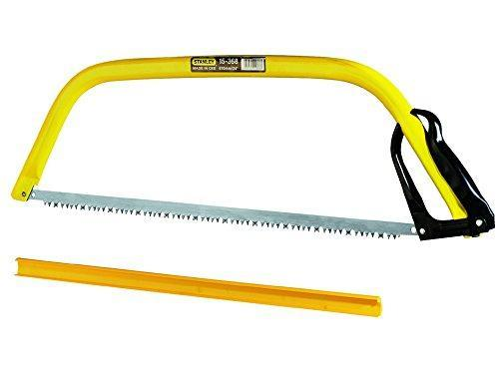
Bow Saw Procedure –
For cutting lengths of wood in 2.
Skills supported Improved fine and gross motor skills; co-operative work (if working with a partner, saying ‘to me to you’ to get a rhythm of forwards and backward motion, then allowing the other to pull).

How to use it safely

• No gloves on tool hand; well-fitting glove on non-tool hand. Gloves need to be a really good fit otherwise grip on the working material can be compromised.

• Maintain a safe distance. Always use tools at a distance at arms’ length and one tool’s length away from other people – Blood Bubble.

• Establish expected behaviour. : To ensure everyone clearly understands all instructions and expected behaviour for safe tool use. Anyone misusing a tool intentionally will be required to put down the tool, and step away, until they are ready to behave appropriately and join in again.

• Ensure proper demonstration and supervision. Adult ratio 1.1 or 1:2.

• Keep both legs to one side of the saw. Always put the protective guard on when not in use.

• Only adults to remove/replace sheaths/guards unless participants are competent.

• Use standing in an upright position.

• Make a groove in the wood first. Use the full length of the saw, drawing backwards. Keep it straight! Repeat this until a reasonable groove has been formed. If working with a buddy, then one pushes and the other pulls the saw.

• Push and pull the saw back and forth in the groove you have made until you have completed the cut. If you are working with a buddy, then one person pushes and the other pulls until you have cut through the wood.

Passing Keeping blade facing downwards, turn the handle to offer to the other person.

Placing Always return to its designated place when not in use.

Cleaning Use cloth and WD40 to ensure all dirt and moisture is off the blade.

Storing In large tool Bag provided. With protective sheath/ cover on.

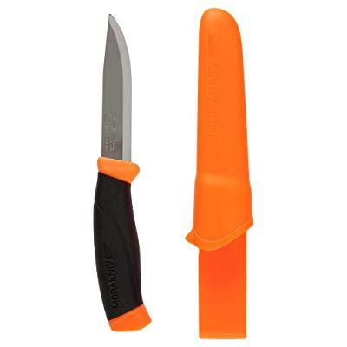
Knife Procedure –
For whittling, carving and cutting.
Skills supported Improved fine and gross motor skills, spatial awareness.

How to use it safely

• No gloves on tool hand; well-fitting glove on non-tool hand. Gloves need to be a really good fit otherwise grip on the working material can be compromised.

• Maintain a safe distance. Always use tools at a distance at arms’ length and one tool’s length away from other people – Blood Bubble.

• Establish expected behaviour. : To ensure everyone clearly understands all instructions and expected behaviour for safe tool use. Anyone misusing a tool intentionally will be required to put down the tool, and step away, until they are ready to behave appropriately and join in again.

• Ensure proper demonstration and supervision.

•You must remain seated. Keep blade facing away from you on the outside of your body.

• Always keep in designated place.

• Sheath immediately after use.

• Only Adults to remove/replace sheaths/guards unless participants are competent.

Passing Holding sheathed part, offer handle to person. Do not walk around with knife.

Placing Always return it to its designated place when not in use.

Cleaning Use cloth and WD40 to ensure all dirt and moisture is off the blade.

Storing Store with protective sheath/cover on, in the Tool bag provided.

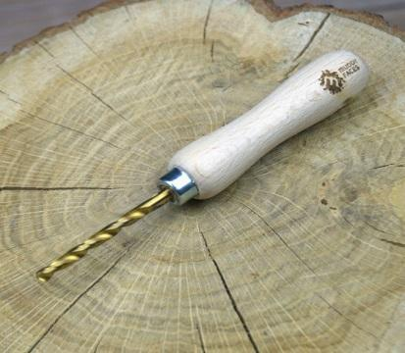
Palm drill Procedure –
For drilling holes into wood.
Skills supported Improved fine and gross motor skills, spatial awareness.

How to use it safely

• No gloves on tool hand; well-fitting glove on non-tool hand. Gloves need to be a really good fit otherwise grip on the working material can be compromised. It is better to have no glove and a safer grip than a glove that is too big.

• Maintain a safe distance. Always use tools at a distance at arms’ length and one tool’s length away from other people – Blood Bubble.

• Establish expected behaviour. To ensure everyone clearly understands all instructions and expected behaviour for safe tool use. Anyone misusing a tool intentionally will be required to put down the tool, and step away, until they are ready to behave appropriately and join in again.

• Ensure proper demonstration and supervision.

•You must remain seated. Keep the tip of the drill facing away from you.

• Use a suitable hard surface to place the wood on in order to drill through.

• Always keep in designated place.

Passing Holding tip with gloved hand, offer handle to person. Do not walk around with the Palm drill.

Placing Always return it to its designated place when not in use.

Cleaning Use cloth and WD40 to ensure all dirt and moisture is off the blade.

Storing Store in the Tool bag provided.

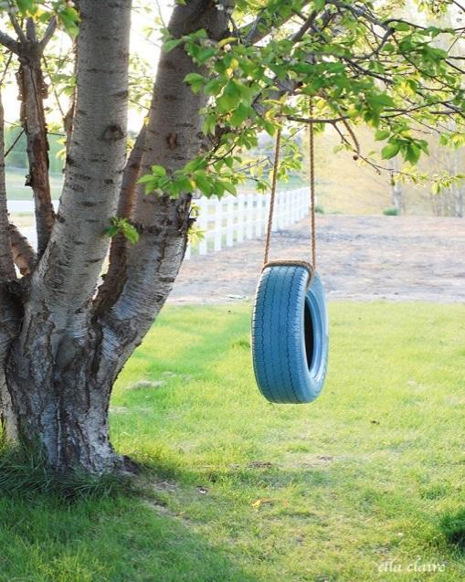
Rope Swing Procedure –
For children to take a risk
Currently not in use
Skills supported Improved gross motor skills, Taking a risk, risk assessing.

Children will not be allowed on the rope swing if:
- There is dead wood in the tree canopy.
- Their clothing is unsuitable including wearing jewellery and flimsy footwear- easily caught on the tree or swing.
- An adult is not within sight- an adult must be able to supervise this activity, even from a distance.

Forest School offers children the opportunity to manage risk, therefore if a child wishes to use the rope swing they need to do it independently.
An Adult may show children where to put their feet and give verbal encouragement but they may not help the children.
If a child is on the rope swing and panics or can’t get off, encourage them to ask their friends to help them where possible and an adult can give step by step instructions on how to get themselves off. If a child is very distressed and cannot get off or stop the swing independently then an adult may intervene and lift them down, taking care of their own back.
One child may be on the swing at a time and the rest of the group need to keep a safe distance.
If a child falls from the swing an adult must ensure the child isn’t hurt and if necessary, the Forest School Leader will administer first aid. Parents will always be informed if a serious injury occurs as soon as possible to decide whether the child needs to go home.

Hammer and Nails Procedure
To construct. Joining pieces of wood together.

Skills supported Improved fine and gross motor skills, spatial awareness.

How to use it safely

• No gloves on tool hand; well-fitting glove on non-tool hand. Gloves need to be a really good fit otherwise grip on the working material can be compromised.

• Maintain a safe distance. Always use tools at a distance at arms’ length and one tool’s length away from other people – Blood Bubble.

• Establish expected behaviour: To ensure everyone clearly understands all instructions and expected behaviour for safe tool use. Anyone misusing a tool intentionally will be required to put down the tool, and step away, until they are ready to behave appropriately and join in again.

• Ensure proper demonstration and supervision.

• Ensure the hammer is being used correctly.

• If need be ask a friend to help you hold the wood in place, ensuring hands are a distance from the nail that is being hammered.

• To return to the designated place.

Passing Offer handle to person.

Placing Always return it to its designated place when not in use.

Cleaning Use cloth and WD40 to ensure all dirt and moisture is off the hammer head.

Storing Store in the Tool bag provided.
Using a Hammer and nails

NEVER use a hammer with a loose or broken handle. The hammer head could come off whilst in use and cause an injury.

Holding a hammer
When starting to drive a nail, grip close to the hammer head. Once the nail has gone into the wood, hold the hammer like you are shaking hands with someone.

- Place the nail where you want to drive it and hold it between the thumb and forefinger of your non-working hand (the hand with the glove on). Hold it near the top of the nail.
- Tap the nail lightly until the nail has sunk into the wood enough that it can stand on its own.
- Then holding the hammer in the hand shaking position tap the nail until it is through both pieces of wood and the top of the nail is flat against the wood.
- Ensure the other end of the nail isn’t sticking out the other side. If so use the hammer at an angle to flatten it against the wood.

Food hygiene procedure
The Forest School Leader holds a level 3 Food Hygiene Certificate. Food hygiene regulations should be followed when cooking on the open fire.
- Split open food and check it is cooked before consumption.
- When cooking with a stick use green wood and remove bark before cooking using a potato peeler. Check plant species to ensure that the wood is not toxic.
- Food must not be reheated.
- Avoid foods that need a lot of fat to cook in case of pan fire.
- A glove must be worn when handling hot pans that are being used to cook food.
- Ensure children tuck in long hair and tie and roll up or fasten loose clothing.
- Check that the client group does not suffer from food allergies or that other reasons, such as religious beliefs, do not prohibit individuals from handling or consuming certain food types.
- Must be school bought food that is used.
- Food needs to be cooked to safe food practices.

When handling and eating campfire food, hands must be cleaned by using soap and water. If unavailable use antibacterial wipes or hand gel.
Food should be stored appropriately before the session and transported to Forest School in a hygienic airtight container.
Food containers should be taken back to be cleaned/disposed of appropriately and no litter should be left behind.

Please refer to the fire risk assessment for further information and guidance when using fire to cook food.

Daily Operating Procedure
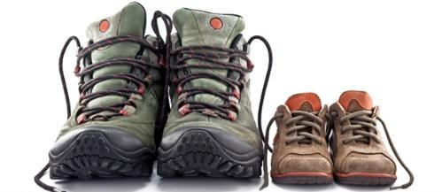

What to do before the session
Before the session begins the daily risk assessment will be carried out by the Forest School Leader
All equipment and tools will be checked.
It Is the Forest School Leaders responsibility to ensure all Staffing and volunteers/helpers are present and signed in for the session on the daily register. They will also have to sign in when they arrive at school which is the responsibility of the Office team.
The Forest School Leader will ensure the register and any other relevant paperwork needed is collected and taken over with the group to the site.
During extremely hot weather children will be monitored and will be encouraged to have plenty to drink and will be sat down in the shade for periods of time.
Clothing
Unless the weather is unsafe, Forest School will run. Children arrive at school in their Forest School clothing which should consist of the following: -
- Old Trousers (e.g. jeans) NO SHORTS
- Long sleeved top/jumper
- Wellies/Walking boots/sturdy shoes
- A waterproof coat
NO JEWELLERY SHOULD BE WORN FOR SAFETY
Depending on the season/weather children will also need to bring the following which may be required: -
- Hat/scarf/gloves
- Fleece/jumper
- Sun hat and sun cream, which must be applied by the child themselves.
Children also need to bring a change of clean clothes with them, including underwear, so they can change if need be.

Forest School Session plan
The aim of the sessions are to encourage children to interact with their environment and give them the opportunity to learn through real experiences whilst participating in child-led play. The overarching aim is to provide open ended opportunities for the children to thrive and enhance their holistic development, whilst promoting resilience, confidence, independence and creativity. Individuals will therefore increase self-esteem, empathy, social skills, problem solving and reflection to name but a few.
Note: Please see pages 4 and 5 of this handbook for more information.
Session routine: Tuesday AM – 9 till 11
Safety reminders: (Children will recite these once they have been learnt) 3 points of contact when climbing a tree, pallets must no be left standing up on end and must be supported so they are stable, Nuts, berries and mushrooms – do not touch them or put them in their mouth. If touched by accident wash your hands.
Our agreements: Bee Kind Bee Gentle Bee Respectful Bee Awesome
Time | Where | What
9am | In classrooms | Get ready – get changed if need to. Waterproofs, wellies, and coats on, collect snack and water bottles to bring to FS.
9.10am | FS site within school grounds. | Walk to FS area. Register, eat snacks, FS agreements, Safety reminders,
9.15am | Forest School | Freely chosen, Personally directed, intrinsically motivated activities.  Following activities require ratios:  Tool use – see risk assessments and procedures.  Fires – see risk assessment and procedure.  Other activities may need adult modelling and possibly continued adult support for some children.
10. 40am | Forest School | Tidy up  Check kit/resources as they are returned – count in  Clean any equipment.
10.50am | Forest School and classroom/cloakroom | Possible group game or sit spot.  Circle time – sharing with the group: -  I enjoyed……….  I am good at……………….  (name) is good at…………  I have learnt…………………. etc.  Thoughts and feelings.  Return to class – remove outdoor clothing and change into shoes.  Get ready for lunch


Activities available include
Pens/pencils/charcoal etc. for writing or drawing.
Wool for weaving, making gods eyes,
Bug hunting – Pots, magnifying glasses, jeweler’s loupes etc.

Mirrors for mirror walks
Sticks for building dens etc.
Making habitats for birds and animals

Tool use

To name but a few……..
Sit spot at the end of the session so the children can learn to relax and enjoy some quiet time to themselves. This is to promote the children’s well-being and an opportunity to enjoy the natural environment around them – the sounds rustling trees, flying insects), smells (fresh cut grass, flowers) and touch (wind/sun on their face).
Note: There are times when children will request to do a sit spot at the end of the session.
Talking time using a talking stick: Each child Has the opportunity to share what they have enjoyed doing or show us what they have found/made etc.
Note: Pass the stick on to the next person if you do not want to share.
Children are also given the opportunity to request things they would like for the next session. However, there are sessions when children are happy to continue playing their games from a previous session so there may be no requests.
Fires are had throughout the year (not daily) to teach the children about the safety but also for the children to understand that it is a tool i.e. we can cook on it, it gives us light and it gives us warmth etc.

What to do during the session
Throughout the session, the Forest School Leader and other staff will be responsible for carrying out ongoing risk assessments to ensure nothing dangerous is being carried out. They will also be continuously head counting to ensure all children remain within the Forest School site and do not leave without permission from a school member of staff.

What to do at the end of the session
Before leaving the Forest School site a head count will again be carried out by the Forest School leader. All tools will be counted and checked and placed back in storage. Once the children have been returned to class the adults will give feedback on how the session went and anything that needs addressing or changing etc.

Forest Schools Daily safety check list
Date - | F/S Leader: | Sara Star
Am - PM - | Signature:
Weather -
Hazard | Checked | Action Taken
Canopy Layer/ Shrub Layer - deadwood in trees and fallen/loose branches | No mature trees at present
Ground Layer - Litter, uneven ground, Brambles, Stinging Nettles, animal faeces
Slippery Areas and standing water - excessive mud, Icy patches
Fire site - Fire pit cleared of debris and area safe for children to enter,
Boundary - Fencing is secure and not broken or damaged. Ensure gate is locked securely. | High Top fencing very secure area
Field Layer - Eye level branches, Poisonous plants, thorns, funghi etc.
Vandalism - evidence of intruders
Any other hazards

Safeguarding children at Forest Schools 
Our school safeguarding policy is filed in the school office and leaflets are located at the reception desk, and this is adhered to at all times. If you have any concerns about a child these must be passed on to a designated Safeguarding Lead (Named below) and this will be reported immediately using CPOMS (a computer programme used by school to report safeguarding concerns). The completion of this should be by the adult who witnessed and or was disclosed alongside the Designated safeguarding Lead. CPOMS is accessible on a laptop or ipad and can be accessed from the school building, so an additional adult would be requested by phoning reception in order for the member of staff to return and complete CPOMS. I have a mobile phone with me so the adult can also phone a designated Safeguarding Lead for advice if they are unsure about anything or need another adult to be able to release the person who has been disclosed to.
Head Designated safeguarding Lead Francis Thacker fthacker@wicklewoodschool.co.uk 01953 602333
Rachael Wolstenholme rwolstenholme@wicklewoodschool.co.uk 01953 602333
DSL’s are immediately notified that there has been a report and will take the necessary steps. This policy will also inform you of the accusation process and again anything of the sort needs to be reported to the Designated Safeguarding Lead and management. Any required forms can be found in the staffroom. Our school safeguarding policy can be found at: https://docs.google.com/document/d/11dXQik3wFPfq5FaKKk7yT-bpvHgiaUdL/edit?usp=drive_link&ouid=109118390532562717214&rtpof=true&sd=true
However please see below the following key points taken from our school policy:-
- PROCEDURES FOR MANAGING CONCERNS

5.1 The Halcyon Federation adheres to child protection procedures that have been agreed locally through the Norfolk Safeguarding Children Partnership. Where we identify children and families in need of support, we will carry out our responsibilities in accordance with Norfolk Local Assessment Protocol and the Norfolk Continuum of Need Guidance.

5.2 Every member of staff including volunteers working with children at our school are advised to maintain an attitude of ‘it could happen here’ where safeguarding is concerned. When concerned about the welfare of a child, staff members should always act in the interests of the child and have a responsibility to take action as outline in this policy.

5.3 All staff are encouraged to report any concerns that they have and not see these as insignificant. On occasions, a referral is justified by a single incident such as an injury or disclosure of abuse. More often however, concerns accumulate over a period of time and are evidenced by building up a picture of harm over time; this is particularly true in cases of emotional abuse and neglect. In these circumstances, it is crucial that staff record and pass on concerns in accordance with this policy immediately to allow the DSL to build up a picture and access support for the child at the earliest opportunity. A reliance on memory without accurate and contemporaneous records of concern could lead to a failure to protect.

5.4 It is not the responsibility of school staff to investigate welfare concerns or determine the truth of any disclosure or allegation. All staff, however, have a duty to recognise concerns and pass the information on in accordance with the procedures outlined in this policy.

5.5 The Designated Safeguarding Lead (DSL) should be used as a first point of contact for concerns and queries regarding any safeguarding concern in our school. Any member of staff or visitor to the school who receives a disclosure of abuse or suspects that a child is at risk of harm must report it immediately to the DSL or, if unavailable, to the alternate designated person. In the absence of either of the above, the matter should be brought to the attention of the most senior member of staff.

5.6 All concerns about a child or young person should be reported without delay and recorded in writing using the agreed system in the setting (see Appendix 1 for suggested template). Records should include:
• a clear and comprehensive summary of the concern
• details of how the concern was followed up and resolved
• a note of any action taken, decisions reached and the outcome

5.7 Following receipt of any information raising concern, the DSL will consider what action to take and seek advice from the Norfolk Children’s Advice & Duty Service (CADS) as required. All information and actions taken, including the reasons for any decisions made, will be fully documented.

5.8 All referrals will be made in line with Norfolk Children’s Services procedures as outlined in Appendix 3.

5.9 If, at any point, there is a risk of immediate serious harm to a child a referral should be made to Norfolk CADS immediately. Anybody can make a referral in these circumstances. If the child’s situation does not appear to be improving the staff member with concerns should press for re-consideration by raising concerns again with the DSL and/or the Head of School. Concerns should always lead to help for the child at some point.

5.10 Staff should always follow the reporting procedures outlined in this policy in the first instance. However, they may also share information directly with Norfolk CADS, or the police if:

- the situation is an emergency and the designated senior person, their alternate and the Head of School are all unavailable;
- they are convinced that a direct report is the only way to ensure the pupil’s safety.
5.11 Any member of staff who does not feel that concerns about a child have been responded to appropriately and in accordance with the procedures outlined in this policy should raise their concerns with the Head of School or the Chair of Governors. If any member of staff does not feel the situation has been addressed appropriately at this point should contact Norfolk CADS directly with their concerns.

All staff are given regular safeguarding training and are informed of any updates we need to be aware of immediately. Training is also refreshed at the beginning of the school year.

Contact numbers if needed:-
If CADS (Children’s Advice & Duty Service) need to be contacted you can contact them on 0344 800 821.

Norfolk County Children’s services can be contacted on 0344 800 8020

LADO ( for allegations against adults working/volunteering with children) can be contacted on 01603 223 473

These contact numbers are displayed on our safeguarding board situated in the staffroom above the photocopier.

Appendix 1: Draft Recording Form for Safeguarding Concerns

Staff, volunteers and regular visitors are required to complete this form and pass it to [ENTER NAME OF DSL] if they have a safeguarding concern about a child in our school.

Full name of child | Date of Birth | Class/Tutor/Form group | Your name and position in school

Nature of concern/disclosure
Please include where you were when the child made a disclosure, what you saw, who else was there, what did the child say or do and what you said.

Time & date of incident:

Who are you passing this information to?
Name:

Position:

[Ensure that if there is an injury this is recorded (size and shape) and a body map is completed]
[Make it clear if you have a raised a concern about a similar issue previously]

Your signature:

Time form completed:
Date:

Body Map

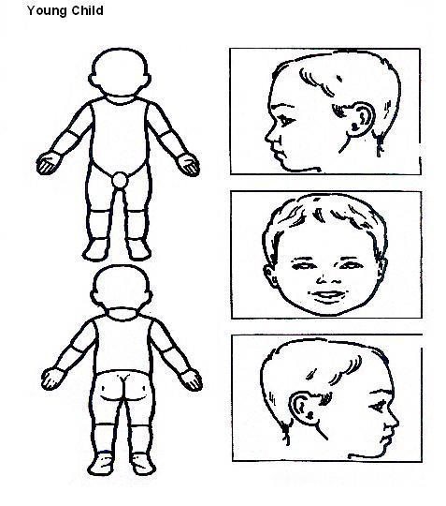

Indicate clearly where the injury was seen and attach this to the Recording Form

Confidentiality Procedure
All information given regarding the children will remain confidential and staff will be told on a need to know basis. Any paperwork will be filed by the Forest School Leader in their folder and kept in a secure lockable cupboard. Photos and videos of children will remain on the school server and will not be shared or used outside of school without the appropriate authorisation for those children’s parents prior to doing so.
Whole school policy can be found at:
https://docs.google.com/document/d/1T_lGJU1cxAXLBMUwwwNL-1FCr1sAn_5r/edit?usp=drive_link&ouid=109118390532562717214&rtpof=true&sd=true
Complaint Procedure
The school complaints procedure will be adhered to in this instant. If a member of staff is approached about a complaint, then this should be referred to the Forest School Leader who will inform management and discuss the best way forward, whether it be a phone call, meeting etc. There are times when the PLO (Parent Liaison officer) will contact the parent themselves to discuss the issue. If the parent/carer wants to make it an official complaint the necessary paperwork needs to be submitted.
Whole school policy can be found at:
https://drive.google.com/file/d/1tG598sh-roSJCN560EJ2iL9DBGwuzIn_/view?usp=drive_link
DBS Checks
All adults need to be DBS checked to ensure suitability of volunteers. LSA’s/TAs will already have obtained their DBS. DBS checks are filled in with the support of a member of the office staff. Once they have been sent off volunteers can begin to assist, however they must not be left alone with a child or take children to the toilet.

Equality within Forest School

All pupils will be given the opportunity to participate in all Forest School Activities regardless of age, ability or gender.
The Forest School programme promotes children's right to be strong, resilient and listened to by encouraging pupils to develop a sense of autonomy and independence.
- All pupils will be respected and their individuality and potential recognised, valued and nurtured. Forest School activities and the use of Forest School equipment will offer pupils the opportunity to develop in an environment free from prejudice and discrimination.
- Pupils with exceptional needs will be admitted to the Forest School programme after consultation between teachers, parents (where appropriate) and Forest school practitioners. The Forest School programme will recognise the wide range needs of pupils and consider what part we can play in meeting these.
- All pupils should be adequately dressed to ensure that they are able to take part in all Forest School activities. A list of required clothing will be sent to parents/carers and these clothes can be kept in school.
- Appropriately sized personal protective equipment e.g. work gloves, and fire mitts will be available for all participants.

Relationship policy
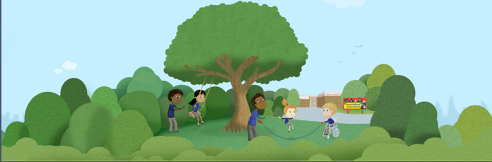
Everyone, including staff, volunteers and participants, have a responsibility to protect their own and other group members' health, safety and well-being. They should inform staff if anybody's actions are likely to jeopardise the safety or comfort of others. We aim to promote:
• Self-esteem
• Self-awareness of personal abilities and limitations
• Respect and care for oneself, other people and the natural environment
• Co-operation and non-violent communication.
Forest School Agreements and Ground Rules will be made between the staff and all children at the start of their first session. This will include items such as respecting oneself, each other and the environment and listening carefully to instructions when they are given. The group will be encouraged to contribute to the agreements before it is ‘sealed’. Ground rules are firmer non-negotiable rules, such as ‘no violence’ and will be explained along with the consequences of breaking them i.e. 2 rule reminders, then removal if dangerous behaviour continues.
We will work with each group to develop a clear set of boundaries and guidelines. Each child will have the opportunity to voice their own feelings. Talking about how they wish to be treated and listening to the feelings of others is important as it will allow the group to work together, understand one another and ultimately become more supportive and cooperative. It will also contribute to making the forest school a safe and enjoyable space. De-escalation if a situation arises where children are behaving in a way that threatens the safety of the group, the forest school leader will call an emergency circle time and encourage discussion of new strategies and possible agreements so similar situations don’t arise in the future. In all these cases the forest school leader will record this on Arbor and inform class teachers as well as the parents/carers. If behaviour is deemed dangerous, it is the leader’s responsibility to deal with this appropriately. In some cases, it may be necessary for children to have ‘time out’ or leave the session early. Any decision to remove a child should be carefully considered alongside the benefits of Forest School.
Positive behaviour management strategies used in school will also be used in Forest School. Please refer to the Relationship policy in the school office for further detail. Children will be reminded about school rules with regard to how they treat other children/adults. Children who are new to the Forest School site will establish their own set of ‘agreements’ (with guidance from the leader). These may include - How to look after each other/equipment/flora and fauna in the site, boundaries etc.

Should bullying occur during Forest Schools it will be dealt with in the same way as school would deal with i.e. It will be recorded onto an incident form and logged on Arbor.

Whole school relationship policy can be found at:
https://drive.google.com/file/d/1PwX1pRIXzwocrb72F8WUFHZZ_dYQ2oPe/view?usp=drive_link

Behaviour expectations for leaders, assistants and visitors: -
● Be a positive role model for participants, particularly with regards to respecting each other and the environment.
● Encourage and reinforce caring and nurturing behaviour.
● Be vigilant with regards to common sense safety.

Forest School at Wicklewood Primary School

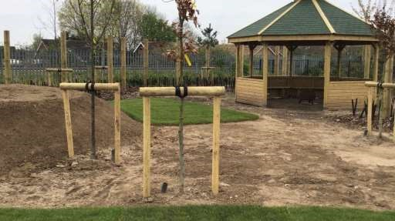

Information for supporting staff and parents

September 2025

What is Forest Schools?
Forest Schools has developed from the Scandinavian education system and arrived in the UK in 1993. Forest School sessions offer children and young people the opportunity to building self-esteem and independence through exploring and experiencing the natural world. Forest Schools is a long term program delivered by trained practitioners within a natural environment. The ethos of Forest Schools allows learners the time and space to develop skills, interests and understanding through practical, hands-on experiences. Activities are child initiated and therefore child led, they could be anything from building a rope swing to making art from natural materials. Children are encouraged to make their own choices and to take supported risks.

Why have Forest Schools?
An increasing body of research shows that Forest Schools has a measurable impact on children, which can then positively influence the participant back in the classroom. Forest School sessions help children develop holistically (social, emotionally, physically, mentally, and intellectually) whilst having fun.

Skills that are developed include:

-communication skills -imagination
-responsibility -problem solving
-decision making -leadership
-negotiation -respect for the natural
-social skills -risk management
-confidence -cooperative play
-fine and gross motor skills -concentration
-observation skills
-imagination
-resourcefulness
-resilience
-persistence

Play Cycle

Here at Wicklewood Primary School we value the play cycle to help us understand children’s play and how best to support it. This also shows how adult intervention can affect or disrupt the play.

“The Play Cycle has proved, and continues to prove to be an effective way to observe and map the process of play. This has implications not just for playwork, but anyone who is in contact with children in a play capacity (parents, childcare workers, early years workers, play therapists). This can be in the home, park, open space, school, in essence everywhere children play.”
Dr Pete King, Lecturer on childhood studies and play at Swansea University
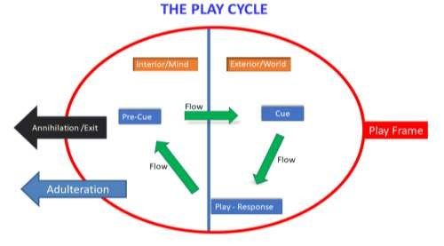
Pre-Cue - The thought or idea in the child’s head that will start the whole process. An instinctive feeling, thought, fantasy or idea sparks the desire to play. The Pre-Cue can also be referred to as the meta-lude. Cue - Is the process of the child transmitting their thought or idea out into the world. It is an invitation, enticement or action issued to others to create play. The Play Cue can be quite subtle, such as making and holding eye contact, or it can be a more obvious action. Whatever the Play Cue looks like, it needs to be taken up by someone else in order for the Play Cycle to continue.
Play – Response - This happens when the Cue of one child is picked up by another child or other children and they respond to it, activating play.
Flow - The cycle or cycles of Play Cues and Play Responses that follow. As the play progresses, it triggers more Pre-Cues and Play Cues which in turn trigger more Play Responses. At this point, children can seem caught up in play and completely engrossed by it.
Play Frame - The physical or imaginary boundary within which the play takes place. This could be the Forest Schools area or perhaps an imaginary dragon’s den! The Play Frame can also be an agreed set of “rules” for the game or even just an understanding between the participants. So long as the Play Frame remains intact, the play cycle can continue.
Annihilation - This occurs when one of the children involved in the play, either the child who made the initial play cue or one of the others, ends the play.
There is another way that the Play Cycle can end and that is known as Play Adulteration. This is when the Play Cycle is broken by an adult who has not been involved in the play.
The adults role in the play cycle
When an adult becomes involved in the Play Cycle, it is usually in one of four ways; however, each way has the potential to disrupt the Play Cycle.

Play Maintenance - Where the adult remains outside of the Play Frame and passively observes the play. Here, the adult can check that the Play Cycle remains intact and is not disturbed by external factors. In this way, the Play Cycle is allowed to continue through its natural Flow and, eventually, Annihilation.
How this can disrupt the Play Cycle:
When observing play, especially when it may involve an element of risk, an adult might feel the need to intervene. Whilst this is triggered by a genuine concern, the Play Cycle is, nevertheless, shut down.
Simple involvement - Occurs when the adult might be just inside the Play Frame but remains passive. The adult does not participate in the play but may act as a resource to further facilitate the Play Cycle and to maintain it. For example, a child wants a cardboard box to use as part of their play. Not being able to find one, they ask the adult, and the adult provides them with one to use.
How this can disrupt the Play Cycle:
The adult, acting as a resource, might suggest or provide something other than what was requested. This is often done to try and be helpful or offer the more logical choice, but it changes the Play Frame and disrupts the Play Cycle.
Medial Intervention - demonstrates a more active role in the Play Cycle. The adult may take up the Play Cue offered by a child and issue a Play Return in response. The adult then becomes part of the Play Cycle.
How this can disrupt the Play Cycle:
Once involved in the Play Cycle, the adult might play in a way unsuited to the child and the initial Play Cue. This can cause frustration, disappointment or boredom, causing the child to end the Play Cycle.
Complex Intervention - Where the adult becomes even more involved in the Play Cycle by both responding to and issuing their own Play Cues. This then causes the child to respond to the Play Cues of the adult.
How this can disrupt the Play Cycle:
The adult might issue too many Play Cues to direct the play and the child will stop responding. In this case, the adult has effectively taken over the play and the child can once again feel frustration, disappointment or boredom and bring the Play Cycle to an end.

Recommended videos to watch that explain the play cycle/Ludric Process:-

https://youtu.be/dSacWWtto4E?si=tqUN22x9XPmzNU2-

https://youtu.be/jkT8J2wUVG0?si=Yk-MXizNsmFgJFfb

Who runs Forest Schools?
Forest Schools will be led by Ms Farish who is a level 3 Forest School lead and first-aider. If Ms Farish is unavailable your Child’s session will be cancelled. The sessions will take place on the school grounds or in Sir Fredericks’s Wood which is adjacent to the school. Sessions will be a morning or afternoon;

What do children need to bring?
Children should come to school in their Forest School clothing, ensuring no jewellery is worn including earrings. Forest School clothing consists of –
-sturdy footwear (bring wellingtons in a bag)
-trousers/Long sleeved top to protect arms and legs from bites, stings and ticks. Old clothes are recommended
-waterproof coat and trousers
-hat and/or gloves and Sun cream if necessary
Please note that we will run Forest School sessions in all weathers except extreme conditions where safety could be an issue. So, come prepared!

Information for assistants
Before the session begins, you must ensure you read this leaflet thoroughly and read all procedures and risk assessments that are shown to you.
All volunteers in Forest Schools need to have a DBS carried out. This is something the office will arrange for you before you begin assisting at
Forest Schools. You will be able to assist whilst your DBS is being processed, however you will not be allowed to be on your own with a child or taking any child to the toilet etc.

Supporting adults inc volunteers
Please wear appropriate clothing – I recommend you wear trousers to protect your legs from bites, stings and ticks – no skirts or shorts below the knee. Bring a water bottle and a snack if you would like one. Please ensure mobile phones are placed in a locker at reception (reference our safeguarding policy which all-supporting adults have training on).

What is expected of you
It is important that you are………………………………
Playful yourself
Encourage participation
Allow children to lead you and let them be in control
Allow children to repeat activities
Ensure they feel safe
Allow them to get dirty/muddy
Allow the children to be alone if they wish to be
Allow safe risk taking
As a helper, we ask you to observe the children and interact where it is deemed appropriate. Please show a positive approach to all
situations/scenarios. Throughout the session, we will all be supervising, risk assessing and ensuring all children are accounted for.

We have agreements that the children are asked to adhere to. These are addressed at the beginning of every Forest School session and we will all abide by these:
- Be kind
- Be Gentle
- Be Respectful to everyone and everything • And Be Awesome
Some reminders

No eating anything found in the site only food made specifically during the session as well as their own snack that you and the children bring with them to the site. Children must be reminded not to put their fingers or hands in their mouths or noses.

Children needing the toilet use their class toilets. A member of staff needs to be made aware they are going and once they have returned. Please inform the Forest School Leader if you need to use the amenities.

Tools will be demonstrated at the beginning of the session as a reminder of correct and safe use and storage. A copy of the tool procedures will also be available.

If children are climbing trees, please ensure you supervise but from a distance so that the children are not necessarily aware that you are doing so.

Please inform the Forest School leader of any injuries and or accidents immediately so they can be dealt with, treated, and recorded where necessary.

We hope you enjoy your Forest School experience with us and would like to take this opportunity to
thank
you for your support.
If you have any questions or any feedback let the Forest School leader know. Feedback is always appreciated and will help us plan future sessions

If you are a parent/carer and would like to volunteer please contact the office on office@wicklewood.norfolk.sch.uk or telephone 01935 602333.
Thank you for reading this information. We hope you have found it a useful introduction to Forest Schools.

Sara Star
Forest Schools lead and Play Manager

