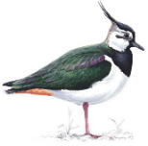
Lapwing Class Home Learning
26th April 2024

Essential Skills

- Reading
- Times Tables
- Spellings

Reading
Please continue to read at home this week. We are aiming for a goal of having everyone in Lapwing reading at least 5 times each week!

Library books can be exchanged when read, although is not expected that a child will finish reading their library book every week, particularly if they have chosen a challenging or longer text.

Reading at home should be recorded in reading records, which can be brought into school everyday as children will read throughout the week and will need to record it in their reading records.

I have attached some reading comprehension style questions for you to have a go at if you would like.

Times Tables
Please practice Times table rockstars this week. Children should have a gig to complete this week.
In class we will be practicing our times tables regularly but the more the children practice their times tables the more confident they will become.

If you do not have access to TTRS please let me know and I can provide log in details or alternative options.

Spellings

Please find below (and on Spelling Shed), this week’s spellings to practise at home. There will be a short test of these spellings next Thursday. I have differentiated spellings this week so some children will have different spellings than others so to find out which set of spellings your child should be practicing please look on Spelling Shed.
Please encourage your children to practice their spellings every day.

This weeks spelling words are:

Main Spellings: Differentiated spellings:
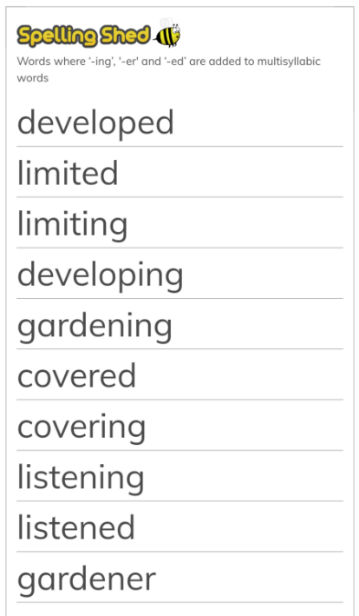
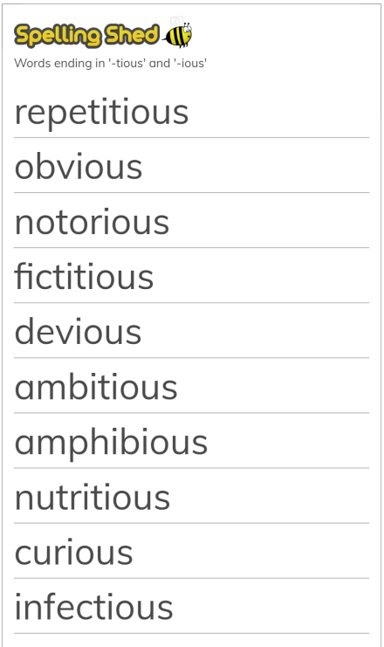

Reading Comprehension
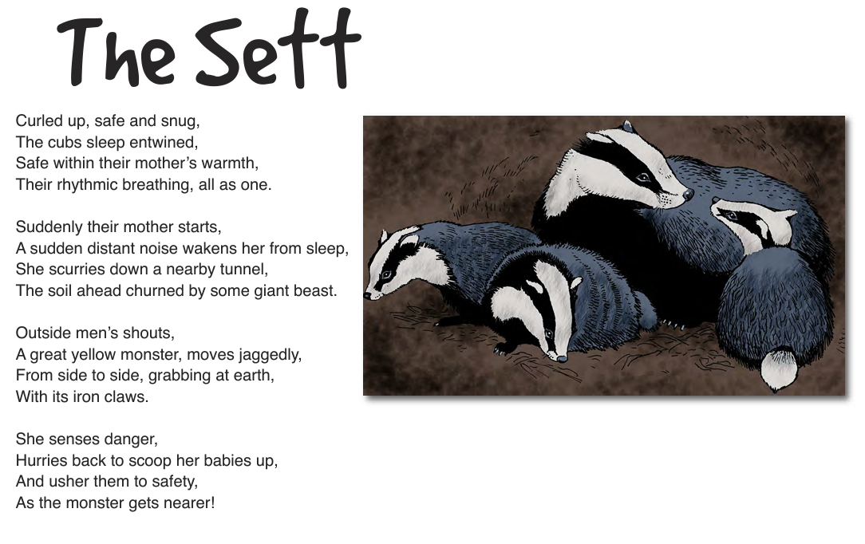

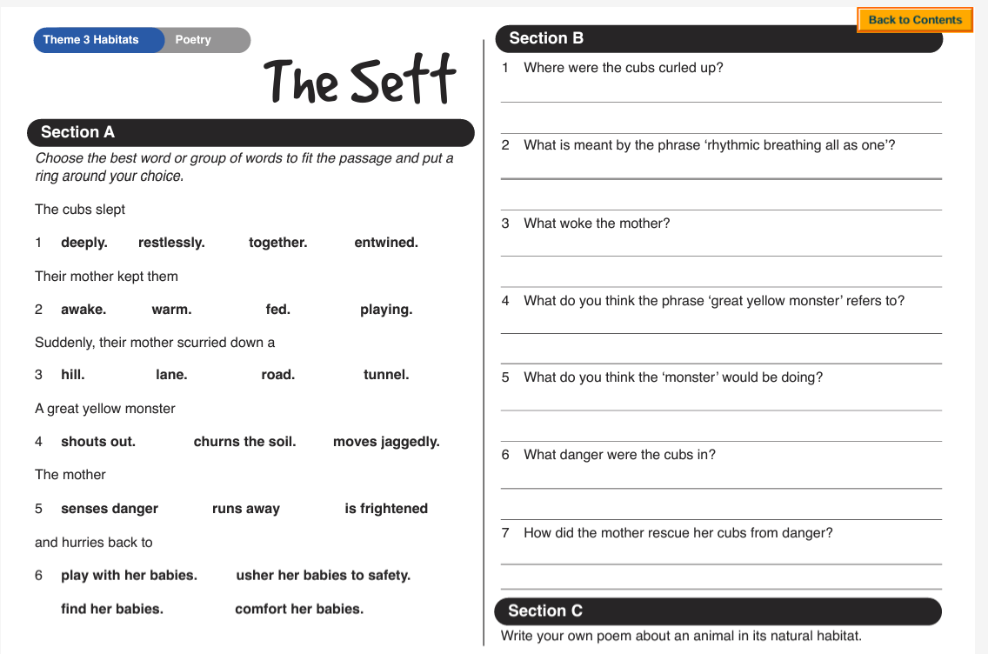

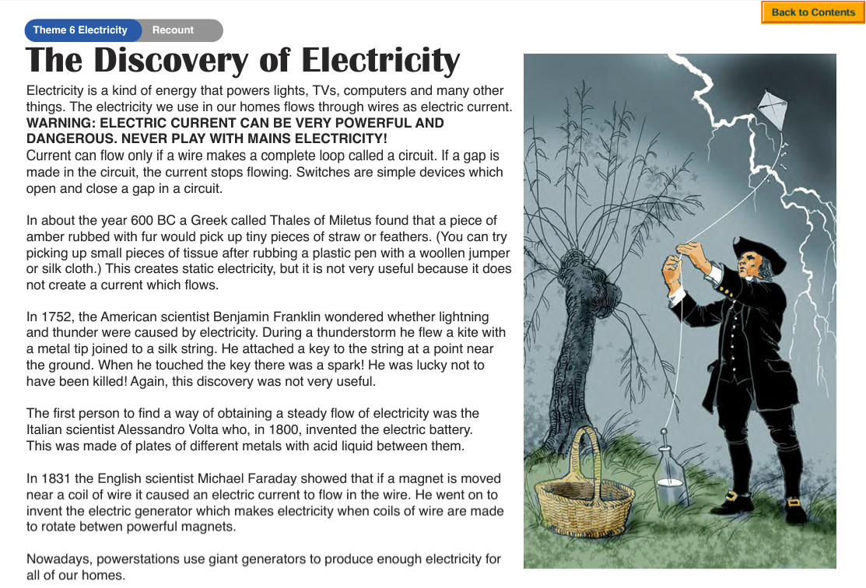
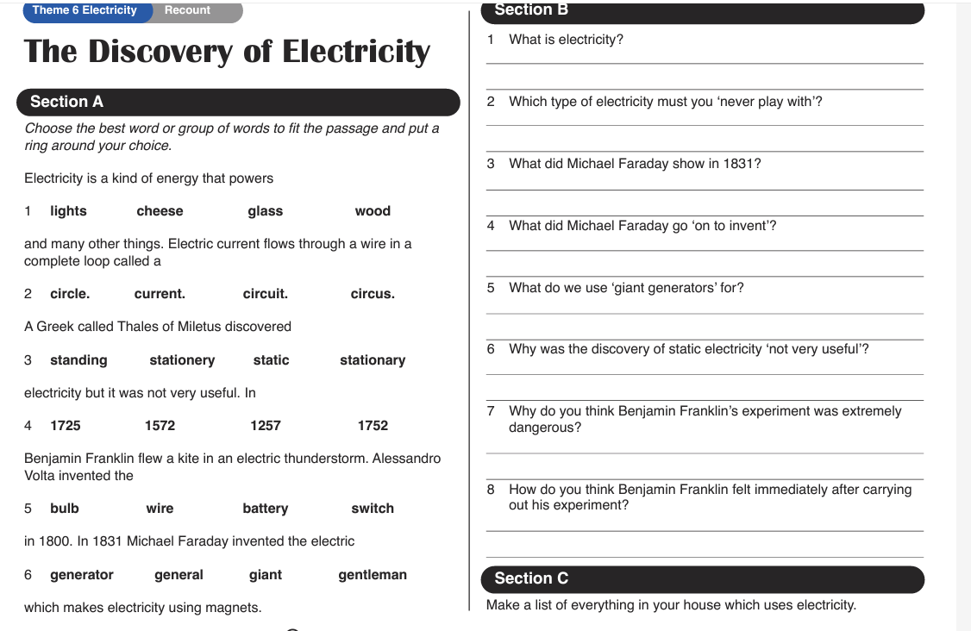

Maths


